NMI/Starmet Reuse Planning Committee Report

Draft Report – March 18, 2021

Executive Summary
- Introduction, Background, and Context
- Committee Process and Data Gathering
- Specific Issues
3.1 Risk Communication
3.2 Liability Assessment
3.2 Housing Considerations
3.3 Recreational Overview
3.4 Potential Ownership Options and Legal Institutional Arrangements
3.5 Finance Considerations
3.6 Town Strategic Planning and Coordination
3.7 Relevant examples of Superfund redevelopment
- “Master Plan” Concept and Potential Reuse Options
4.1 “Master Plan” Redevelopment Concept
4.2 Illustrative Potential Reuse Options
4.2.1 Option 1: Municipal, Community, Recreational Focus
4.2.2 Option 2: Private/Commercial/Office Use Focus
4.2.3 Option 3: Mixed Use Focus - Housing, Retail, and Commercial Uses
5. Recommendations and Next Steps: A Roadmap to Redevelopment

Annex A: Nuclear Metals, Inc. Site Reuse Assessment Summary Report
Annex B: Community Survey Results and Comment-Response Matrix
Annex C: Examples of superfund cleanups with relevance to NMI/Starmet site reuse
Annex D: Consent Decree
Annex E: U.S. EPA Municipal Liability Protection Information

Executive Summary

The Concord Select Board established the Nuclear Metals/Starmet Property Reuse Planning Committee (NSRC) in June 2019 to initiate planning for future use of the superfund site located at 2229 Main Street. With site clean-up expected to be completed in five to seven years, Concord needs to understand the issues involved in its future use along with reuse options and their alignment with current plans and community priorities. This report summarizes the NSRC’s work over the past 22 months to identify and clarify critical reuse issues for Concord and formulate a master plan concept to guide future redevelopment.

The cleanup of the site has been in progress for many years and the final design for the removal of remaining contamination is well underway. As a lienholder at this site, and as a municipality with jurisdiction over its future use, Concord has a unique opportunity to acquire the site and then shape and benefit from its restoration and redevelopment.

Located between Route 62, Forest Ridge Road, and the Thoreau Hills neighborhood in West Concord, this 46-acre site includes a nine-acre former commercial site with large, level areas for buildings, parking and other structures. There are forested, untouched wooded hillsides that back up to Concord Conservation land and trails. There is a thousand-year-old sphagnum bog – a priceless wetland that attracts unique flora and fauna, and of course birdwatchers. In a few short years, this site will be cleaned up and prepared for whatever redevelopment is in store.

Recognizing what a great opportunity it could be to shape the restoration and redevelopment of the site, Concord Town meeting voted in 2015 to give the Select Board the authority to take ownership of the property at 2229 Main Street. In order to begin the process, the NSRC has reviewed several potential reuse options for the site that would be of greatest benefit to the community and identified several issues to report back to the Select Board. Related to this basic charge, the NRSC is providing input to the EPA regarding the design of the cleanup so as to identify and realize optimal redevelopment opportunities for the site.

The site has been under scientific investigation as well as cleanup actions for many years under the direction of the U.S. Environmental Protection Agency (EPA) and the Massachusetts Department of Environmental Protection (MADEP). Contamination at the site occurred as a result of a specialty metals research and production facility that was operated by several private defense contractors from 1958 to 2011. The U.S. EPA placed the NMI site on the Superfund program’s National Priorities List in 2001 and, with the Town’s input, developed a detailed plan to remediate and restore the site. The plan, as codified in a legally binding “Consent Decree” and guided by strict cleanup standards, is fully funded and is currently being implemented. The efforts of the potentially responsible parties (PRP) group - the Settling Federal Agencies (SFAs) (U.S. Army and U.S. Department of Energy) and two private parties, the Settling Defendants (SDs), Textron and Whittaker) - to investigate and clean up the site have been and continue to be closely overseen and monitored by EPA and Town committees.

The decision on acquisition of the site will presumably hinge on the range of potential redevelopment options, full knowledge of the potential uses as well as the financial and liability issues inherent in such a purchase. In order to evaluate Town options, the Select Board formed the Nuclear Metals, Inc./Starmet Reuse Planning Committee (NSRC) and charged it with the mission to consider and recommend potential reuse options for the site that would be of greatest benefit to the community. Related to this basic charge, the NRSC is also was to identify key issues for the Select Board to consider.

As part of the planning process, the NSRC received assistance from the EPA and its contractor, Skeo, to conduct a public workshop that collected community input on redevelopment. The committee also met with, and briefed, several Town committees to share initial ideas and concepts and to receive additional feedback. With input from EPA and the cleanup contractor, de maximis, the site was divided into several potential development zones (Figure E-1) which served as the basis for developing a “Master Plan” redevelopment concept and for considering various options and examples of those options for future development.

Figure E-1. NMI/Starmet Site “Redevelopment Zones”

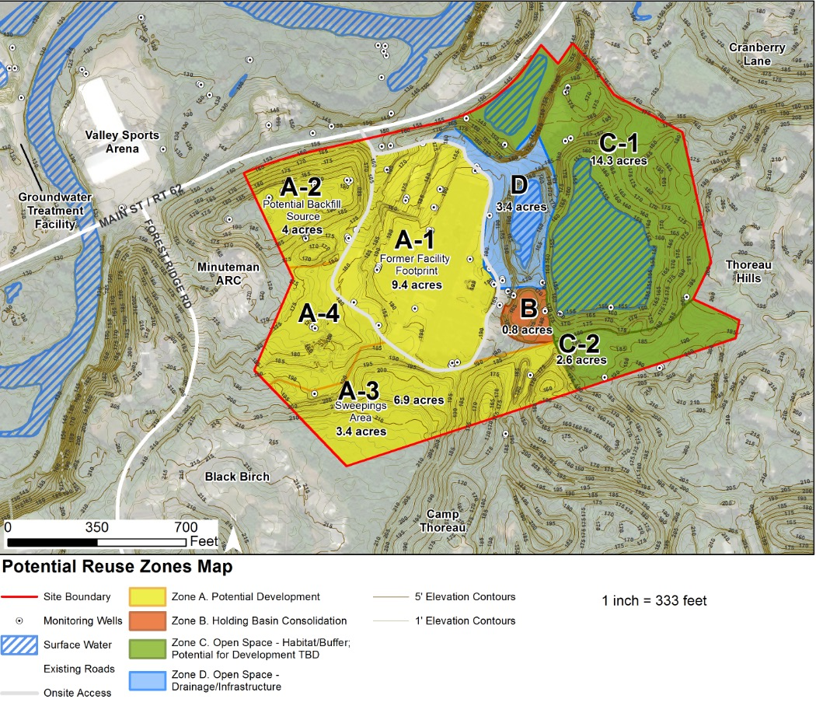

The development of the Master Plan and potential examples were based on several key guiding principles:

Multiple Integrated Uses: Redevelopment should address multiple needs identified by the community.


Environmental Stewardship: Redevelopment should be sustainable and preserve environmental assets, be carbon-neutral, and improve landscape resilience.

Fiscal Sustainability: Find creative way to fund reuse.


Community synergy: Strengthen the community and our relationships with neighboring towns. Provide opportunities for people from diverse social groups to interact as they access services at the site, and support site accessibility to local neighborhoods and surrounding communities.

Focusing on a “Master Plan” redevelopment concept (see Figure E-2) and several more specific potential options, the report first considers several issues relevant to redevelopment, including:
- risk communication around environmentally contaminated sites,
- evaluation of future possible liability and related considerations,
- appropriateness and need for housing at the site,
- recreation needs of the Town,
- potential options for taking ownership of the site,
- finance considerations,
- context of other Town development efforts, as well as
- relevant examples of other Superfund site redevelopment.
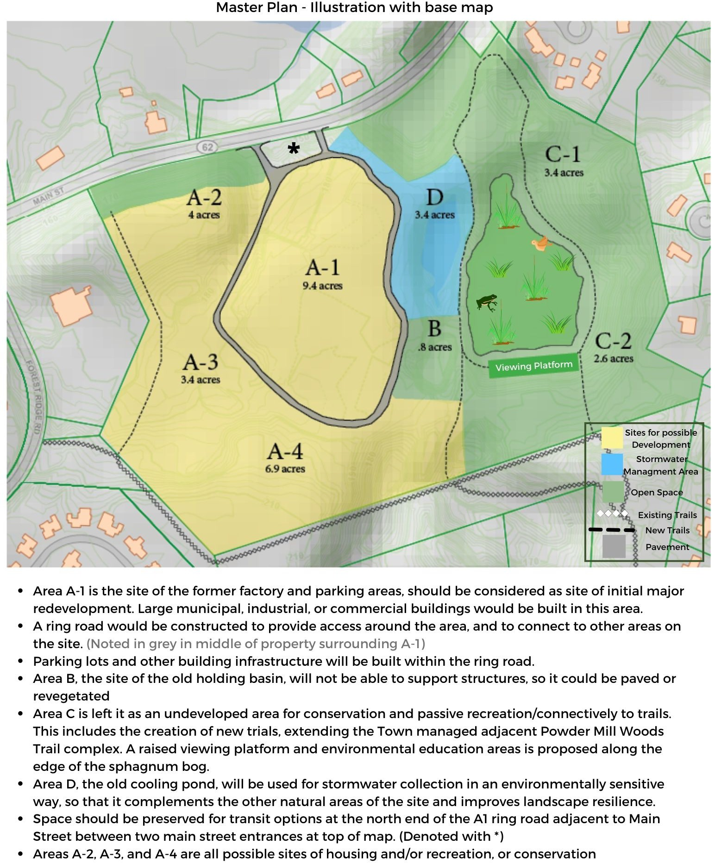
Figure E-2. NMI/Starmet Site “Master Plan” redevelopment concept

The report then presents several illustrative redevelopment options within the larger context of
the redevelopment “Master Plan.” All options include the conservation of at least half the site, including unique ecological features, for public use and enjoyment. The other half of the site could include additional possible conservation elements, or potential redevelopment options, for example:

- Option 1: Municipal, Community, Recreational Focus
- Option 2: Private/Commercial/Office Use Focus
- Option 3: Mixed Use Focus - Housing, Retail, and Commercial Uses

Each of these is detailed further in the report, with examples of some of these options or variants on them.

The report concludes with recommendations and next steps for the Town of Concord Select Board to consider based on the NSRC’s findings. As a key to the careful redevelopment of the site, the NSRC strongly recommends that the Town of Concord begin planning to take ownership of the parcel at 2229 Main Street and to start active planning for the “Master Plan” concept for redevelopment of the site. Key short-term actions for the Select Board to consider include: (i) engaging the Town Counsel to become fully informed on the means and mechanisms for minimizing future liabilities and to understand existing liens on the property, if any, and (ii) to develop a next-phase planning mechanism for the site’s redevelopment, beyond the NSRC’s initial charge. Finally, in the near term, the Select Board should (iii) initiate a human health risk communication effort, which is important for public acceptance of redevelopment and future use of the site.

Longer term, the Select Board should (i) consider several principles of redevelopment based on the NSRC’s review of issues in this report. The Town should also (ii) consider engaging with third parties to gauge demand for various redevelopment investments and partnerships and (iii) begin a process of coordinating NMI/Starmet Site redevelopment planning with other efforts at other sites and facilities in the Town. In parallel with this coordination, the Town should, with input from the Finance Committee, (iv) undertake a fiscal impact study to better understand the costs and revenues to Concord under the different reuse options.

Introduction, Background and Context
In April 2018, the Select Board developed the charge for the Nuclear Metals, Inc./Starmet Reuse Planning Committee (NSRC) to consider potential reuse of the 46-acre Superfund site that would be of greatest benefit to and for the community. Committee members were appointed in May 2019 and conducted a site visit in June 2019 to learn about the site’s history and initial reuse suitability analysis with the intent to conduct a community-wide meeting and open house in the fall of 2019 to identify potential uses for the site, which could then inform the next phase of cleanup efforts.
Through the efforts of EPA Region 1 and EPA’s Superfund Redevelopment Initiative (SRI), the consultant group, Skeo, worked with the EPA Region 1 site team to develop a framework for the reuse assessment, then worked with the NSRC to integrate the technical analysis, stakeholder engagement and facilitation support with the EPA’s site activities and the Town’s planning process. The support provided Skeo, included: outreach to bring stakeholders to the table; exploring community land use goals; clarifying cleanup goals, process and constraints; integrating land use goals into the cleanup process as feasible; and identifying long-term stewardship options. The result was the March 2020 Nuclear Metals, Inc. Site Reuse Assessment Summary Report (see Annex A).

ABOUT THE SITE’S RECENT HISTORY OF USE
At the Nuclear Metals, Inc./Starmet site (the NMI site), several private defense contractors operated a specialty metals research and production facility from 1958 to 2011. Textron, Inc. and Whittaker performed special metals research and development for the U.S. Atomic Entergy Commission and the U.S. Department of Defense from 1958 to 1972. Company employees then assumed ownership at the site, operating as Nuclear Metals, Inc. (NMI) and began producing depleted uranium (DU) ordnance products for the Department of Defense. During operations, DU handling and disposal practices resulted in contamination of the facility’s production building, equipment, and site soil, sediment and groundwater. DU production at the facility ceased in 1997, and the company reorganized as the Starmet Corporation and shifted manufacturing to the production of beryllium alloy components and spherical metal powders.
Starmet completed interim cleanup actions overseen by the Massachusetts Department of Public Health Radiation Control Program in 1998. The EPA placed the NMI site on the Superfund program’s National Priorities List in 2001 and has since overseen the efforts of the potentially responsible parties (PRP) group (that includes the two private companies Textron and Whittaker) and the Settling Federal Agencies (SFAs) (U.S. Army and U.S. Department of Energy) to investigate and clean up the site through de maximis, Inc. the environmental contractors designing and performing remedial actions on behalf of the PRP and SFA under EPA supervision. Starmet permanently abandoned the facility in 2011.
To date, including the period prior to the site’s designation as a Superfund site in 2001, the various agencies and parties have completed site investigations and multiple removal actions, including removal of chemicals, demolition of facility buildings, and construction and operation of a groundwater treatment facility (See Timeline in Figure 1.1). EPA selected the NMI site’s final clean-up plan in the 2015 Record of Decision. The involvement of local organizations and town committees, including the chartered 2229 Main Street Committee, helped inform community input into the 2015 Record of Decision.

Figure 1.1 Timeline of NMI/Starmet cleanup process.
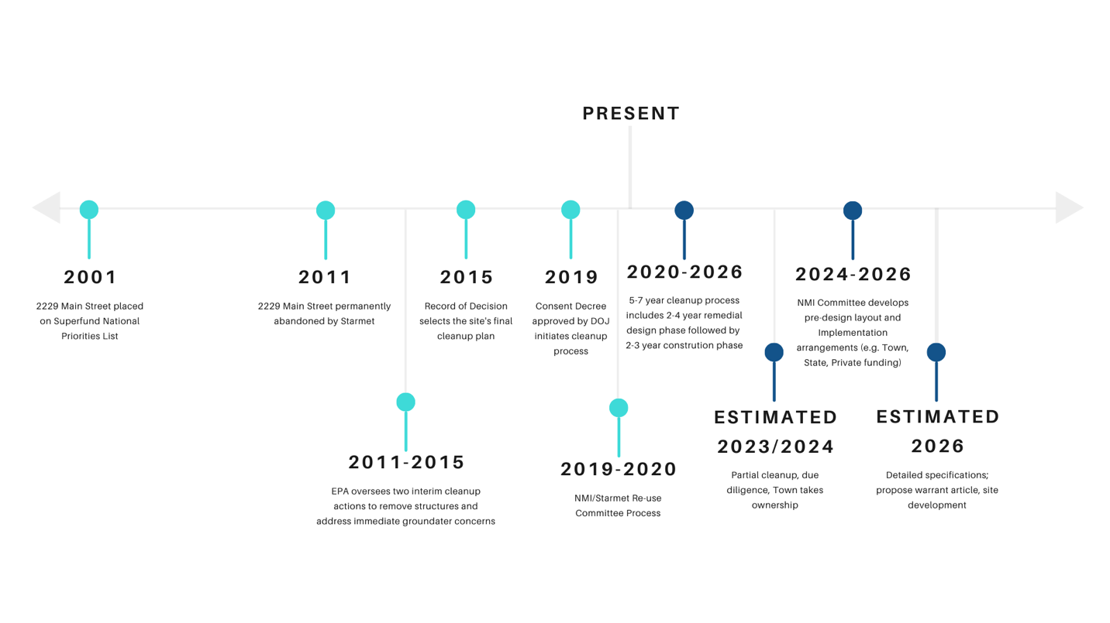

SITE CHARACTERISTICS AND FEATURES
The NMI-Starmet site (Figure 1.2) is located in the southeast portion of Concord off Main Street/Route 62 at 2229 Main Street, near Concord’s western boundary with the towns of Maynard and Acton as well as its southern boundary with Sudbury. It is about a mile west of West Concord village, a mixed-use commercial center with an MBTA commuter rail station, and about 2 miles from Route 2, 11 miles from Interstate 95 and 25 miles from Boston.
The property is comprised of 46.6 acres, of which approximately 4.5 acres is wetland. The site is currently zoned Limited Industrial Park 1, which allows for the following uses, either by-right or by special permit: forestry, agriculture, conservation, private recreation, combined industrial/business/residence, planned residential development, educational, child care facility, religious, philanthropic, lodge and club, municipal use, underground and aboveground utility, large ground-mounted solar voltaic installation, indoor amusement, financial and business office, professional office, parking facility, transportation services, warehouse, R&D and light manufacturing, and, manufacturing, packaging, processing and testing.

Figure 1.2 NMI/Starmet parcel located at 2229 Main Street in West Concord.
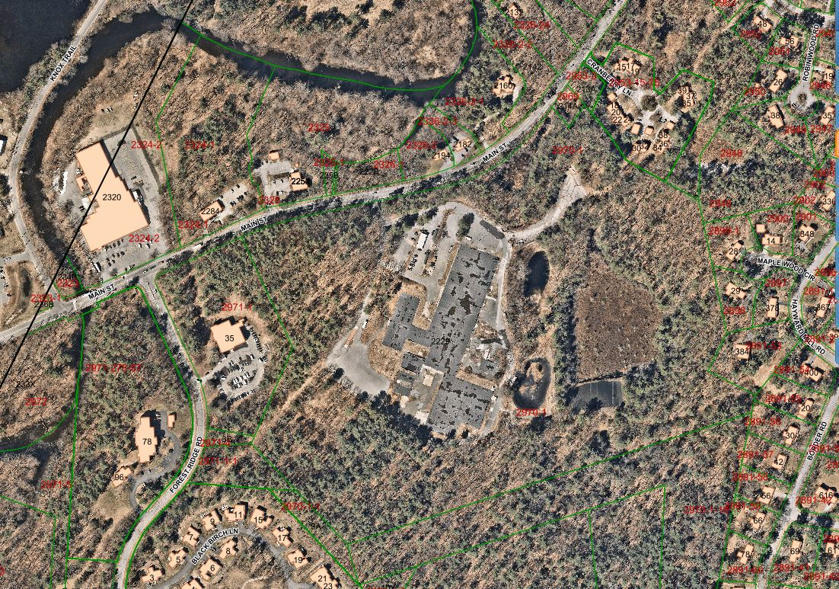

The NMI site currently includes (Figure 1.3) the building slab of the former manufacturing facility, former parking lots, forested areas, and wetland areas, including a sphagnum bog and a large retention pond referred to as the cooling water recharge pond. The building slabs and impacted sub-slab soils will be removed as part of the remedy.
The property is surrounded by residential, industrial, recreational, and office uses (Forest Ridge Road Limited Industrial Park with residential, recreational and commercial office uses to the south and west; Thoreau Hills and Cranberry Lane residential neighborhoods to the east; Town trails; and Route 62/Main Street residential/commercial/industrial uses and the Assabet River across Main Street to the north). Current access to the site is limited to a single entrance from Main Street and a driveway that surrounds the former facility.

Figure 1.3 Building slabs adjacent to holding basin, cooling water recharge pond and sphagnum bog
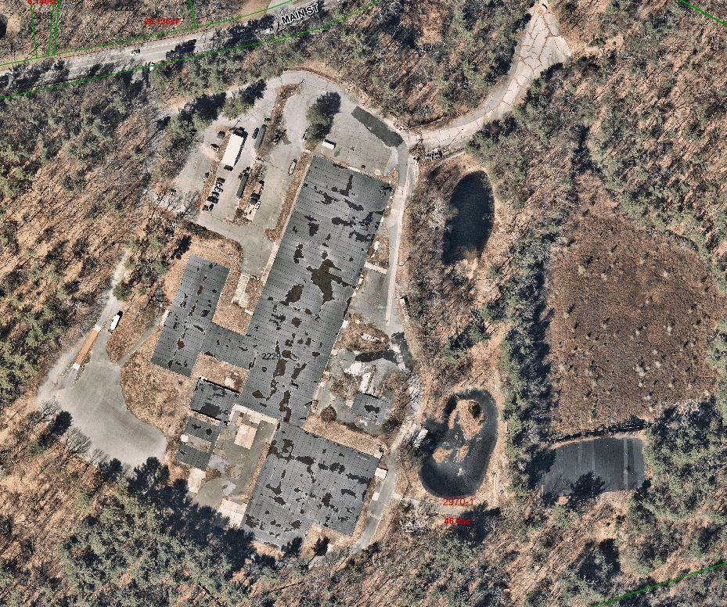

Based on these characteristics, existing conditions, and future use limitations, and in collaboration with the NSRC, Skeo and de maximis, identified several distinct areas or “zones” within the site as a basis for planning the reuse (See Figure 1.4 and Table 1.1).

Figure 1.4. Proposed Re-use Zones.
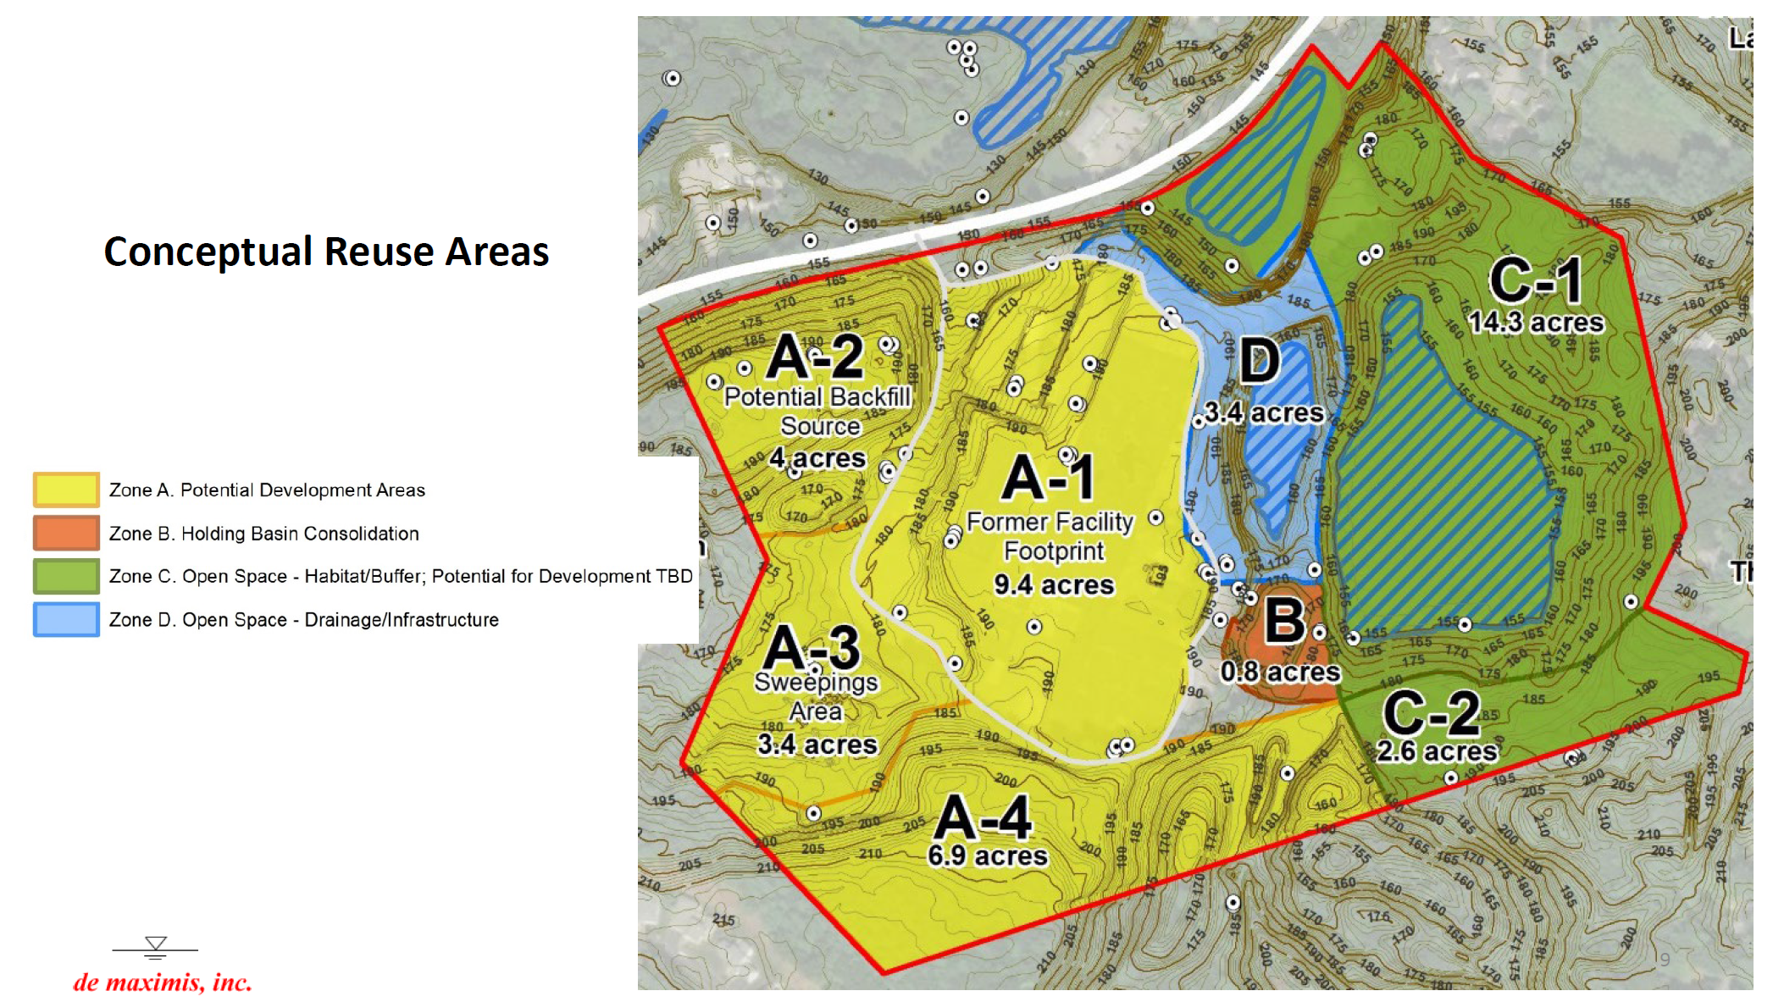
General descriptions of each zone and rationale for their designation are as follows:

Zone A1: This area of approximately 9.4 acres is the location of the heavily modified and constructed zone that originally housed industrial operations at the site. Buildings have been removed and all foundations will be removed, and soil excavated and replaced with clean fill.

Zone A2: The 4-acre wooded, hilly area is located near the entrance to the site and is adjacent to Route 62. The area was never developed nor was it used for waste disposal. The soils in this zone are possible source of clean fill for the backfilling required elsewhere on the site. Such excavations, involving all or a portion of A2, could serve the dual purposes of providing clean fill and at the same time allowing for preliminary preparation of this zone for future development. A net environmental benefit analysis (or NEBA) of using this location for fill vs trucking soils to the site for offsite locations are being assessed by EPA’s contractor.

Zone A3: Also known as “the Sweepings Area” this 3.4-acre zone may be suitable for development. Though originally wooded and somewhat topographically challenging, ongoing excavation of contaminated sweepings will leave this area clean but requiring some restoration.

Zone A4: The zone is heavily wooded and lies directly adjacent to Town property with hiking trails already developed. The zone has some steep terrain in parts.

Zone B: The small area is the location of the holding basin into which site wastes were disposed. The nature of the area and its limited areal contamination footprint will require its future segregation, isolation, containment, and capping.

Zone C (C1 and C2): This 16.9-acre section of the Site is a natural resource asset. Parts of C2 were used for burial of various types of equipment and debris; however, the area will be dug up and restored. Zone C2 overlooks the Sphagnum Bog area and the rest of zone C1 and is a prime area for both viewing of C1 and connecting to offsite trails.

Zone D: This zone contains the cooling pond into which non-contact cooling water and site stormwater drainage flowed while the site was occupied. The steep confines of the pond and its location preclude its development but does afford its inclusion into a site-wide stormwater collection system in the future.
The NMI-Starmet site will be cleaned up to residential standards, the most stringent level of cleanup defined by the least human health and ecological risks of all the possible cleanup alternatives. As a result, the potential development areas could support residential, commercial, light-industrial and mixed-use projects, in addition to municipal uses. Certain limitations, established as part of the site’s remedy, prohibit uses of groundwater, excavation beyond certain soil depths, or most development activities in the Holding Basin Consolidation Area (Zone B). Additionally, groundwater use will be prohibited on the entire NMI site; the property is, and will continue to be, connected to the Town’s municipal water system, which is available from Main Street. Some of these redevelopment zones are limited in terms of potential reuse based on cleanup details and/or institutional controls that will need to remain in place. With the help of EPA’s site contractor, de maximis, the cleanup plans within each of these redevelopment zones were established. Table 1.1 identifies generalized cleanup actions by zone as well as specific limitations on re-use within that zone.

Table 1.1. Proposed cleanup actions and subsequent use restrictions by re-use zone.
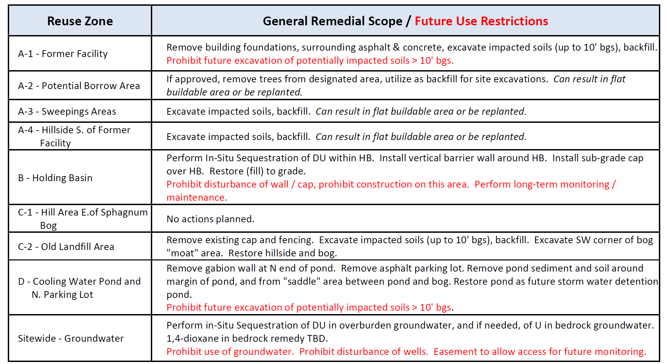

COMMITTEE PROCESS AND DATA GATHERING
The Town, Town committees and other local organizations have been actively involved in the remedial process at the NMI-Starmet site for almost 20 years. EPA supports a Technical Advisory Group (TAG) with representatives from the towns of Concord and Acton as well as a Town committee, known as the 2229 Main Street Oversight Committee, to review all technical aspects of investigations leading to the cleanup decisions. This has helped inform community input into the Site’s 2015 Record of Decision and the TAG and 2229 Main Street Committee remain involved in discussions related to technical aspects of the Site’s clean-up.
The NMI-Starmet Reuse Planning Committee (NSRC) was established by the Town to work with EPA during remedy implementation and to help guide the Select Board in considering future land use and redevelopment recommendations for the NMI-Starmet site. The NSRC was asked to assist the Town with identifying possible ways to reuse the NMI-Starmet site for maximum public benefit. The NSRC members’ responsibilities include:
1. To review the record of environmental contamination and clean-up on the site to fully understand existing and likely future conditions;
2. To hold a public hearing early in the term of the committee to solicit preliminary public comments and suggestions regarding the kinds of public and private uses that should be considered in the re-use planning process;
3. To work with staff and professional consultants to assess each idea for possible reuse activity, including housing, commercial uses, and municipal uses; and,
4. To explore funding opportunities, including federal grants and private funding.
The NSRC’s work began at a June 2019 meeting at the site to view the site and to hear from Bruce Thompson of de maximis, inc., the remediation contractor. The NSRC then began working with Skeo and EPA to research and compile previous planning recommendations, which led to developing a set of principles and goals highlighted in a briefing document used to help gather community input. These principles, based substantially on the ideas presented in the 2018 Comprehensive Long-Range Plan, Envision Concord: Bridge to 2030, were:
- Multiple Integrated Uses: Redevelopment should address multiple needs identified by the community.
- Environmental Stewardship: Redevelopment should be sustainable and preserve environmental assets, be carbon-neutral, and improve landscape resilience.
- Fiscal Sustainability: Find creative way to fund reuse.
- Community synergy: Strengthen the community and our relationships with neighboring towns. Provide opportunities for people from diverse social groups to interact as they access services at the site, and support site accessibility to local neighborhoods and surrounding communities.
The NSRC held discussions in August, September and October 2019 with other town-appointed boards and committees to ensure land use zoning, conservation, recreation, economic development, and housing groups understood key opportunities and constraints in evaluating future redevelopment options for the site. In mid-October, EPA and the Town co-hosted a reuse planning workshop that identified a set of potential uses and general concepts for the NMI-Starmet site. Over 75 residents participated in the two workshops held that evening. Ideas generated and information received during the workshops was then organized by the NSRC members who were asked to develop conceptual models for discussion in December. Three conceptual models were developed: a community recreation center; an office/medical complex that anchors the site with housing and recreation fields complementing the complex; and a mixed-use development, which incorporates housing, indoor recreation/entertainment space, restaurant, office, artist studio/co-workspace and outdoor recreation fields.
In February 2020, the Chairs of the NSRC, the 2229 Main Street Committee and Bruce Thompson for de maximis, gave a presentation to the Select Board, which highlighted the Key Issues and a Timetable with implications for the Select Board. While the NSRC had identified a reuse “Master Plan” concept for the site (See Chapter 4), there were key issues remaining such as: a) consideration of a mixed-use development versus a clustered/phased development approach; b) the number and type of indoor and outdoor recreational uses that would maximize the public benefit; c) the intensity of redevelopment (whether to use area A2 for backfill or leave the area undisturbed; whether and when to develop area A3 and A4; whether more than 50% of the site should remain open space); d) what is the necessary due diligence around financing redevelopment (balance market rate vs. subsidy; 3rd party development; public private or seek grant funding, etc.).
Also, with the U.S. Department of Justice (DOJ) filing of a consent decree in October 2019, which legally commits the four parties responsible for the contamination at the NMI-Starmet site, the Select Board was made aware that: a) it was important to identify what information the Town needs in order to take ownership of the property, as authorized by Town Warrant in 2015; b) risk communication remains an issue that the Town needs to address before presenting a plan to the community; c) there was a general redevelopment framework in progress, with enhanced detail expected by late summer); and, d) that the final plan would need to be considered in the larger context of the Town’s other redevelopment projects (i.e., a new middle school replacement and Peabody School redevelopment, Keyes Road facility, Harvey Wheeler Community Center; and others).

After meeting with the Select Board, the NSRC met and determined where further input was needed with regard to public comments heard during the October workshops:
• Risk communication
• Refine the 3 scenarios developed thus far
• Identify or expand any additional scenarios
• Discuss potential ways to better visualize the three options
• Conduct a Public Forum to gather feedback on aspects of the three scenarios (present strengths and weaknesses of the three scenarios, costs and benefits of various aspects of options, community needs and desires, etc. and how to evaluate feedback)
With the onset of the pandemic and declared State of Emergency from the Governor, the NSRC realized it would not be able to conduct the type of workshop desired to obtain additional information from the public. The NSRC prepared an on-line presentation and questionnaire that was distributed in July and August with outreach through email, press release, the Town’s News & Notices, posters and other social media to alert residents of the survey. Approximately 70 residents responded to the survey. While there was disappointment that the number of respondents wasn’t higher, it was noted that the range of responses was very broad (survey results are found in Annex B).
After reviewing the survey results, the NSRC determined to move forward with its report due to the Select Board in March 2021.

Specific Issues Identified and Considered by the NSRC

Risk Communication
Concordians who lived here in the 1990s might remember NMI as a bustling factory, billowing smoke from its stacks 24 hours a day, adjacent to a shimmering holding basin of unnaturally green sludge where contaminated pickling solution had been dumped outside for the previous 40 years. That company doesn’t exist anymore. Multiple cleanup efforts over the last three decades have removed wastes, obvious contamination and the building themselves. This has culminated in the current and final cleanup effort under the EPA’s Superfund program that will remove or mitigate possible effects of any remaining contamination over the next 2-4 years.

Based on community input and Concord zoning rules, EPA decided that this site would be cleaned up to a residential standard, and the water at the site needs to be cleaned up to the drinking water standard (even though groundwater use from the site will remain prohibited). Guided by the 2015 EPA Record of Decision, the impacted soils, sediments, dredging, buried equipment, and foundations will be dug up and disposed of offsite. A small amount of residual buried source material will be stabilized, capped and entombed in concrete, so that the groundwater is protected. A pump-and-treat system has already been installed to remove solvents from the groundwater plume, and chemicals will be injected into key locations in the metal plume to make the metals insoluble and protect the groundwater further.

Cleaning this up to a residential standard means that once the remediation is complete, any remaining chemical constituents are either at natural background levels or are below very conservative risk levels. Thus a person could live, work, and eat vegetables grown at this site for 70 years without appreciably increasing his or her risk of cancer. Any residual risk is estimated to be negligible based on scientific standards.

However, the company that controlled this site for 50 years did not engender a lot of trust and the stigma of being identified as a “Superfund” site, may cause some Concordians to remain skeptical. Even if these concerns result from misconceptions, the Town will need to address citizen concerns and provide them with regular information about the remediation so they will have confidence that the remediation goals are being met and the site is safe for reuse.

In community meetings, in the survey, and by direct communication, the committee regularly heard several key misconceptions about the site (including some regarding future liability covered in Section 3.2):

Concerns/Misconceptions about reuse:
- “Even after the cleanup, it will never be safe to go there.” Concord residents have expressed concern that this site will never be clean enough to be safe, but there are several facts keys to communicating on this issue:
- Most of the risks have already been addressed at this site through various actions that cost over $80 million. Before it was made a Superfund site, more than 8,000 yards of contaminated pickling solution/sludge were removed from an open holding basin on the site in the late 1990s. By 2015, the buildings at the site were dismantled and disposed of offsite, eliminating prospective air pollution or additional water pollution at the site.
- Remaining risks will be addressed through the expenditure of another $125 million. In 2015, the EPA Record of Decision recognized that Concord zoning allowed for residential uses at the site and designated that all soils and sediments will need to meet a residential cleanup level. This means that thousands of cubic yards of soil will be removed across large areas of the site and replaced with clean fill. Anyone living, working, playing, and even growing their own vegetables in soils from this site after cleanup is completed would be exposed to negligible risk.
- Most of the site was never contaminated. The applies to roughly half of the site. For example, Areas A2, A4 and most of Area C (see Chapter 1) was never used for waste disposal.
- The majority of the cleanup at the site is about protecting the groundwater at the site to mitigate possible offsite impacts. The groundwater is far removed from any onsite contact and deed restrictions will preclude any uses of groundwater. To the user who visits or lives on this property, there is no risk of exposure to any residual, but deeply buried, contamination.

Concerns/Misconceptions about housing:
- “The site is unsafe for housing of all types.” Risk analysis that was used to develop the residential cleanup standard took into account all ages of residents and types of residential exposures. But that still has not alleviated the perception that this site is not suitable for families. This is probably the most difficult issue to overcome, if housing options are to be explored. Many representatives from the affordable housing and disability communities expressed the opinion that affordable housing, elderly housing, or assisted living on a superfund site would give the appearance of environmental/social injustice. They suggested that Concord could use the Superfund site to make money that could support housing at other locations.

The committee sought the advice of Concord resident Peter Lowitt, who helped redevelop Fort Devens. Mr. Lowitt pointed out that housing at Devens was only developed on areas that were not impacted by the cleanup there. Reuse zones A-2 and A-4 are not impacted by contamination or any previous development at the superfund site. Area A-2 abuts Main Street, and area A-4 backs up to the Black Birch development along Forest Ridge Road. Either of these areas could be designated as potential housing, and the discussion about exactly how or if these areas should be developed should be considered as the sitewide remediation is completed. People may feel differently about living at the site if they are using other parts of the site for recreation or commercial purposes.

- “There is no reason to plan for any housing at this site.” Having been encouraged to select a rigorous and expensive cleanup alternative, the Federal Government and other responsible parties will spend hundreds of millions of dollars cleaning up this site to a residential standard because the Concord zoning for this parcel allows for residential use. Given the taxpayer commitments to this most expensive cleanup alternative, housing should not be taken off the table without a discussion as it is rare for such a large, buildable parcel of land to become available in Concord and in light of the Town’s housing needs. Therefore, it is important to consider the possibility of building housing or various types, including affordable housing, at the site.

Development of a Risk Communication Approach to Redevelopment
Knowledge and access allow people to assess the risk more realistically. One of the biggest hurdles that the Select Board needs to address is getting people comfortable with the idea that once the site is remediated, it will be safe to live, work, and visit there. An educational communication strategy is critically needed on the eventual risks at this site in the context of other daily risks – chemical and otherwise – that the public faces every day so that perceived fears can be placed in proper proportion to actual risk.

As part of any risk communication, it will be important to ensure that additional data collected during the cleanup in order to monitor progress (or analysis of those data) is made readily available to the public. Additionally, it will be important to cite examples of other similar Superfund sites that have been successfully redeveloped for human uses. Some of these examples are presented in Section 3.7 and in Annex C.

Beyond the issues of chemical risk, as discussed above, another important strategy that may help people get comfortable with the risk at the site is that of phased development. For example, if recreational trails are extended into the site, and recreational or commercial buildings are built in reuse zone A-1, people could get used to coming to the site to access these facilities, then perhaps they will get more comfortable with the idea of additional development at the site. The beauty and functionality of the site will speak for itself.

Liability Assessment
Superfund sites, acquisition of those sites, and provisions and mechanisms to limit liability are very different from and are covered by different laws those for for non-Superfund-contaminated sites. In the case of the NMI/Starmet Site, the obligations of the responsible parties are codified in the legally binding Consent Decree (CD) (Annex D). In this light, and with special provisions enacted by EPA to help municipalities with acquisition and limitation of liability, the Town needs to understand what liabilities, if any, it would incur if it were to acquire the Site. Any and all of what is described below must be confirmed by Town Counsel at the direction of the Select Board, as part of the specialized “due diligence” for Superfund Site acquisitions.

In the information that follows we discuss and describe:
- That the cleanup of the site and requirements, obligations, costs, and liabilities are fully described in the legally binding CD (Annex D); these include provisions for any post-cleanup future liability.
- That cleanup is fully funded with specific provisions in the CD to get more funding for future “discoveries”, if any, not known at the time of the signing of the CD.
- That all of the presently required cleanup costs have already been deposited in the Cleanup Trust Fund and that, according to CD responsible parties, are and will be available to and be bound to cover all costs.
- That 98% of the obligation and costs – past and future – to address needed remediation will be borne by the two Federal Government Parties – the U.S. Army and the U.S. Department of Energy; the two private parties are only responsible for 1% each of the costs of cleanup.
- That the Town, and municipalities in general, that seek to acquire Superfund sites for reuse are afforded liability protections via several mechanisms. There are two main mechanisms that EPA has developed to assist Towns in this regard and to provide a “liability-limited”, pathway for the Town of Concord to acquire and hence redevelop the site. These are:
  - The Tax exemption provision – wherein municipalities that ”take” a Site for municipal for tax liens, are afforded liability protection.
  - The Bona Fide Prospective Buyer (BFPP) process, wherein the Town meets straightforward requirements so as to avoid any liabilities related to the contamination of the site by the responsible parties.
- That the liens on the property have been researched by EPA and are known. Though Town Counsel needs to confirm this information, one of the important liens, outstanding taxes owed, is held by the Town and will likely facilitate both the purchase and the liability protections described above.
- The Town already has arranged for a 20-year environmental liability insurance policy with elevated per-case limits for the site back in 2015.

Further details to elaborate on these points follow and additional liability protection information provided by the U.S. EPA is provided in Annex E.

    - The cleanup of the site and requirements, obligations, costs, and liabilities are fully borne by the responsible parties (RPs) described in the legally binding CD³
    - The cleanup is fully funded with specific provisions in the CD to get more funding for future “discoveries”, if any, not known at the time of the signing of the CD. All of the presently required cleanup costs have already been deposited in the Cleanup Trust Fund and that according to CD responsible parties are and will be available to and be bound to cover all costs.

Concerns have been raised that the Town could be responsible for any future costs associated with new contaminants discovered, other unknowns, or unforeseeable liabilities. In spite of extensive investigations that have been conducted to date and continue to be conducted in the current design phase of the cleanup, there remains the possibility that a new issue can be discovered in the future. However, the Town, as purchaser of the Site and potential operator/lessor, is not and will not be responsible for preexisting conditions, whether fully know as this time or not.

The Superfund program is geared towards ensuring that the parties responsible for the contamination pay the costs of cleanup. Per EPA as confirmed in the CD, the responsible parties include:

The Settling Federal Agencies (SFAs) – the Department of the Army; the Department of Energy (98% responsibility

The Settling Defendants (SDs) – Textron Inc.; Whittaker Corp (now a subsidiary of Meggitt PLC) (1% responsibility each)

Responsibility for the cleanup includes addressing contamination known at the time of the CD as well as any contamination caused by the responsible parties that may be discovered in the future. The Town is not a “responsible party” at this Site under the Superfund program. The Superfund program and specifically the legal agreement binding all responsible parties, i.e., the CD has clear mechanisms for funding the cleanup and for seeking additional funds from the responsible parties should new problems related to the contamination of the site caused by the RPs. Superfund law published guidance from EPA, and the CD provide prospective owners, especially public entities, with clear risk limitations. The Superfund program was designed with safe ways for municipalities to buy or take ownership of Superfund sites, without taking on any of the liability for unknown hazards that may still be present on the site during an extended cleanup. Even after such a taking, the responsible parties, not the new owner, are responsible for the remediation and still liable if new hazards are discovered.

In summary, the Superfund program provides for a protective remedy (i.e., the CD), and offers EPA the means to modify that remedy and to fund any future actions as needed to keep it protective into the future. In other words, the Town would not assume any liability for existing yet unknown or unforeseeable issues at the site which might cause increased liabilities and costs in the future (e.g., a new chemical that is present but not currently measured; a new regulation causing lower drinking water standard; a buried drum not detected in the Remedial Investigation (RI).

While the Town will not have the burden to provide any future costs for cleanup that may be required, the cleanup will trigger certain restrictions on the use of small areas of the Site (i.e., the cap over the Holding basin; the pump and treat systems that may be located at the site; restrictions as to depths of any foundations that can be dug – 10 feet; etc.). As the owner of the Site, the Town will be required to ensure adherence to these restrictions. To address these “restrictions”, Institution Controls (ICs) are required to be implemented. The preferred form of IC will be a “Notice of Activity and Use Limitation” or NAUL. Implementing a NAUL requires execution by the property owner (i.e., the Town). As there is no current owner available for the 2229 Main Street property, Concord’s acquisition would allow for establishment of a NAUL. Regardless of the form of IC, monitoring and reporting is required:

“In the event of any Transfer of the Affected Property, unless the United States otherwise consents in writing, Settling defendants shall continue to comply with their obligations under the CD, including their obligation to provide and/or secure access, to implement, monitor, and report on [ICs], and to abide by such [ICs]”.

Many, if not all, Superfund sites do have such activity and use limitations, such as ongoing groundwater treatment systems and monitoring wells. It is in the best interest of the EPA and the responsible parties paying for the cleanup to have a responsible owner who can enforce restrictions and protect vulnerable remedies. Thus, EPA is particularly amenable to having municipalities – who are likely to ensure that institutional controls are maintained properly – take ownership of impacted properties.

Finally, only if some contamination occurs at the site after the Town purchases the Site will the Town or the entity causing the contamination (e.g., a leaser) be responsible for that contamination.

    - All of the presently required cleanup costs have already been deposited in the Cleanup Trust Fund and that according to CD responsible parties are and will be available to and be bound to cover all costs.
    - 98% of the obligation and costs – past and future – to address needed remediation will be borne by the two Federal Government Parties – the U.S. Army and the U.S. Department of Energy; the two private parties are only responsible for 1% each of the costs of cleanup.

Concord residents have expressed concern that companies involved in the remediation will cut corners to save money. The parties responsible for 98% of the cleanup costs (hundreds of millions of dollars) are the US Army and the US Department of Energy (together known as the Settling Federal Agencies or SFAs), but two other private companies, Textron and Whittaker (known as the Settling Defendants or SDs) are also responsible for the cleanup. Under the CD, the legal agreement for cleanup of the site described above, and with approval from EPA and the SFAs, contractors to Textron and Whitaker will manage the remediation. The remediation has been, is being, and will be carefully monitored by EPA, progress reported, and data gathered to demonstrate the success of the cleanup effort. This is a fact-based assessment.

Further, the Town has delegated the monitoring of the cleanup to the highly regarded 2229 Main Street Oversight Committee, which has been monitoring the efforts since 2002. That will continue. The SFAs as well as Textron and Whittaker (the SDs) have already fully funded the cleanup. The SDs and their contractor (de maximis) have already shown that they are acting proactively to identify new problems at the site and take care of them quickly. As examples, early in the 2000s, they chose to dispose of barrels of beryllium metal dug up during the remedial investigation offsite, rather than store them at the site for 20 years until the final remediation plan was developed (as would be the normal process). They chose to remove the buildings at the site and dispose of the hazardous building materials offsite even before the Record of Decision was released by the EPA. In 2014, while the ROD was being developed by EPA, new technology allowed them to detect a cleaning solvent, 1,4-dioxane, in a groundwater plume heading under the Assabet River, towards drinking water wells in Acton. This was one of those “unknowns” at the time of the investigations at the site. Because this new chemical was discovered and posed a risk to the Acton water supply, they proactively set up a well for hydraulic control of the plume, and later installed a pump and treat system that already operates at the site, to address the risk of this solvent reaching a drinking water well. They also discovered this solvent in the bedrock and have plans to develop a remediation strategy for that newly discovered plume. In addition, the site contractor in coordination with EPA has already measured levels of the relatively new group of chemicals known as (per- and polyfluoroalkyl substances (PFAS) and had found no issues with regard to that “new” chemical. As new issues arise, additional funding has been and will be requested and committed and these companies have shown that they want to characterize and address them quickly and safely.

- The Town, and municipalities in general, that acquire Superfund sites for reuse and redevelopment are afforded liability protections via several mechanisms.

There are two main mechanisms that EPA has developed to assist Towns in this regard and to provide a “liability-limited”, pathway for the Town of Concord to acquire and hence redevelop the site. These are:
  - The Tax Exemption Provision – wherein municipalities that “take” a Site for municipal for tax liens are afforded liability protection.
  - The Bona Fide Prospective Purchaser (BFPP) process, wherein the Town meets straightforward requirements to avoid any liabilities related to the contamination of the site by the responsible parties.

The CERCLA § 101(20)(D) exemption from owner or operator liability includes circumstances in which the local government acquires title to property “by virtue of its function as sovereign.”⁶ Those functions are spelled out in the document⁶ as:

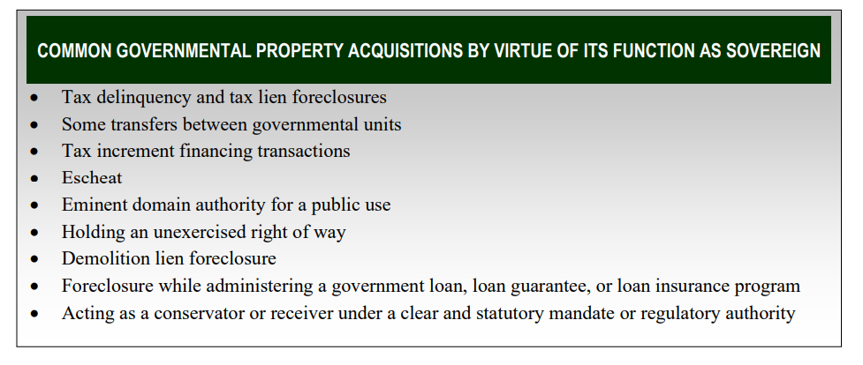

By virtue of the strong likelihood that the Town can acquire the Site based on back taxes (to be confirmed by Town Counsel via conversations and possible negotiation with all lienholders) the Town can be afforded liability protection.

The second mechanism is protection via the “Bona Fide Prospective Purchaser (or BFPP) provision, a self-administered process that affords backup liability protection, if needed:

“The BFPP liability protection in CERCLA §§ 101(40) and 107(r)(1) may be available for a local government that purchases or leases contaminated property if it establishes its BFPP status prior to acquisition and maintains its BFPP status after acquisition. The BFPP protection is self-implementing but requires parties – including local governments – to demonstrate they have met the statute’s pre-acquisition “threshold criteria” and post-acquisition “continuing obligations”…. As another basis for liability protection, the EPA generally encourages local governments to consider layering their available liability protections and to establish and maintain BFPP status even when another liability protection may apply”.

The liens on the property have been researched and are known.

Liens on the property potentially could impede the Town’s acquisition of the Site and must be fully researched and negotiated. However, not only have the financial liens (inclusive of back taxes owed to the Town) been researched by the responsible parties and EPA, but the inclusion of back taxes may facilitate purchase and liability protections noted above. Further, as a clear effort to provide the Town with useful information on outstanding liens, EPA has provided some clarity as to its position on the outstanding Department of Justice (DOJ) lien as follows:

“We are confident that we will be able to release the large DOJ lien against the property once the Town is ready to take ownership. However, in order to do so, there is likely to be one condition EPA/DOJ will need to work with the Town to resolve. The majority of the DOJ lien is on behalf of the Army, which has now many millions of dollars of unreimbursed costs from the Site.
Therefore, when releasing the lien, it is likely that DOJ will simultaneously want to sign an agreement with Concord that states the Town will share a portion of the proceeds if the property is leased or sold. When the time comes, the attorneys will help us work through the negotiations
/ details. But in general, that is the framework in which we envision the DOJ lien getting
released” (Email from C. Smith, EPA Project Manager, 9/23/2020).

A list of outstanding liens has been provided to the Select Board. Town Counsel, with help from EPA, will need to confirm these liens. EPA has recommended that Concord’s existing tax lien against the property could be a reason for Concord to reach out to these other lien holders initially, and that through negotiations, the Town may be able to take the land for back taxes.

- The Town already has arranged for a 20-year environmental liability insurance policy with elevated per-case limits for the site back in 2015.

Some concern has been expressed that if the Town were to acquire the Site a significant and costly amount of additional insurance would be required and that such an acquisition might even be uninsurable. The Committee has recently become aware of the fact that the Town did indeed acquire insurance directly related to the possible purchase of the Site. It remains to be seen, however, if the Town would require additional insurance should the Select Board recommend, and the public approve, of such purchase for specific redevelopment projects. Town Counsel, as part of his due diligence for the purchase, should seek additional details at the proper time.

In conclusion, much information regarding potential liability of the Town in acquiring the Site is known and ways to ensure that the Town does not incur liability exist and can readily be pursued by the Town. All participants have acted with good faith and with openness thus far, and the funding of the cleanup is secure. The EPA has offered to provide “Comfort Letter(s)” to the Town describing and helping to understand and resolve all of the issues mentioned above.

Housing considerations
Several key issues relevant to housing that will help inform the Town's decision-making process in determining (1) whether the Town should take ownership of the Site, (2) whether the Site should be used to develop housing, and (3) if so, what types of housing should be built on the Site are presented below.

A major consideration in reuse planning is the fact that the EPA has decided, and the U.S. Government and other responsible parties have agreed, to fund the remediation of the Site to "S-1 Residential Standards". Thus, the site is being cleaned up at great expense, to achieve “residential standards”, the most rigorous standards which allow for any uses, including residential housing. As part of the success of redevelopment. public perceptions of the Site, as discussed above, are critical to the path of redevelopment, regardless of what, if anything, is ultimately built. Education of the residents of Concord, the public at large, as well as the development community, will be among the most important efforts to be undertaken (see Section 3.1 above).

Given that the Site will be remediated to Residential Standards, there should negligible residual risk to public health and safety, any and all reuses of the site are theoretically possible. This includes various types of residential housing. However, any reuse of the site should not focus on housing alone. Rather, the Town should consider a mix of uses on the Site combining any housing plans with commercial and/or municipal development. Creating a place where a variety of uses can exist together in harmony will help to dispel concerns that housing is being built in a location that is perceived to be otherwise undesirable for any other purposes. Further, while cost should not be the only concern, the Site may represent an opportunity for the Town to offer land for residential development at a substantially lower price than elsewhere in town.

Consistent with the stated goals of the Town's Comprehensive Long Range Plan (i.e. the Envision Concord Plan), the Town should offer an increased range of housing choices. For example, unmet needs include "Workforce Housing", housing options for older Concordians looking to down-size, millennials who grew up in Concord and are now looking to move back in as well as new “affordable” housing that counts toward the Town’s Subsidized Housing Inventory ("SHI") to help meet state goals of at least 10% affordable housing under Chapter 40B.

The Site also represents an opportunity to generate funds for the creation and preservation of affordable housing in locations other than the Site by directing income received from developers specifically for that purpose. The Town could support an option for developers to fund affordable housing elsewhere in Concord through a Payment in Lieu of Units or "PILU" program. Under such a program, a developer can contribute funds to the Town to its Municipal Housing Trust, the Concord Housing Authority, CHDC, or other appropriate entities, rather than develop the units on the Site. One or more of those entities can then use such funds to create or preserve affordable housing units elsewhere in Town as opportunities arise.

Recreation needs assessment overview
Indoor and outdoor recreational spaces are some of the Town’s most valued assets. These assets, under the purview of the Recreation Department with close coordination with other departments (e.g., Natural Resource Commission; Department of Public Works; School Department; etc.) enjoy multigenerational uses. Two recent examples of this multidepartment interdependency were the Summer Camp of 2020 and the in-school hybrid learning, wherein the Recreation Department was able to provide services by virtue of School facilities and the COVID-driven elementary school program was able to continue an in-school virtual learning component through the cooperation of the Recreational Department staff.

While the recreational needs of the Town are rapidly evolving and changing and likely have changed since the issuance of the Recreation Department Strategic Plan, several priorities were defined for the medium and long-term centered around the need for additional neighborhood parks and indoor facilities. The Plan articulated needs for:

- Neighborhood parkland/development.
- Additional playgrounds,
- Additional Youth and adult ball fields,
- Multi-purpose and youth soccer fields,
- Picnic pavilions throughout the system,
- Additional gymnasium, perhaps in West Concord so that there is a balance of resources, and
- Indoor tracks for running and walking. This is an important amenity for a growing, older population.

Though the financing of any developments at the site along these lines is to be determined, and the potential need for Town capital, there is clear public need mixed with quasi-private momentum. For example, the local youth baseball organization, the Concord-Carlisle Youth baseball & Softball (CCYBS), has explicit plans for the privately-funded upgrades of several playing fields in town – Emerson, Rideout, and Ripley – with a significant planned private investment in the Ripley School field to create a Town-wide and regional asset for youth baseball. In addition, the unique “Recreation Commission Revolving Fund” has previously established the stand-alone financial operational model of the Recreation Department, under which the operations of any new development can be funded.

Potential ownership options and legal/institutional arrangements

The most important issue in the next phases of planning and actual redevelopment of the site is the Town’s decision on ownership of the site. In order to form the foundation for public and municipal uses of the site, the Town must take ownership of the site as authorized by a Town Meeting vote at Special Town Meeting in April 2015 under Warrant Article #2. Once ownership is established then the Town can consider various development options.
There are several potential ways in which the Town could manage the property, after taking ownership. Several options are presented below with issues and considerations for the Town to investigate further depending on community input.

Town as owner/landlord
This is perhaps the most straight forward institutional arrangement for acquiring the property. After reviewing and negotiating with current lienholders to eliminate financial liability, the Town could agree to acquire the property (e.g. through tax foreclosure or other legal means). This would also require the Town to take legal responsibility for the institutional controls that will be required at the site (e.g. maintaining the wastewater treatment systems, preserving the integrity of capped holding basin, ensuring groundwater restrictions are enforced, etc.). However, taking direct ownership also minimizes risk to the Town because if the Town is enforcing these controls, we are assured that known environmental risks remains below residential standards achieved through the cleanup actions (See Section 3.2).

This option may come with a significant administrative burden, however, since the Town would then have to potentially negotiate multiple leases/rentals for whatever redevelopment uses are put at the site. Property management of commercial/retail uses may present new challenges for Town Staff.

Town ownership/development through a public development entity
This option involves Concord creating a new public corporation or authority to take ownership of the site and oversee the implementation of the town’s development plans for the site. Massachusetts laws provide for several municipal authorities for this purpose, e.g., Redevelopment Authority and Economic and Development and Industrial Corporation. Such an entity would be overseen by a town -appointed Board of Directors and would provide administrative capacity, via staff and/or contractors to oversee site development and activities. The authority might lease or sell properties to private developers or undertake some projects itself, and provide a means to raise grants funds and utilize site revenue to finance and facilitate site improvements and development uses.

Town as owner/long-term lease w developer
This option involves a ground lease, where a tenant is permitted to develop a piece of property during the lease period and where all improvements are turned over to the property owner at the end of the lease period. Because a ground lease allows the landlord to assume all improvements once the lease term expires, the landlord may sell the property at a higher rate. Ground leases are also often called land leases, as landlords lease out the land only.

Although they are used primarily in the commercial space, ground leases differ greatly from other types of commercial leases like those found in shopping centers and office buildings. These other leases typically don't assign the lessee to take on responsibility for the unit. Instead, these tenants are charged rent in order to operate their businesses. A ground lease involves leasing land for a long-term period – typically anywhere from 10 to 99 years—to a tenant who constructs a building on the property, and in the case of the NMI/Starmet site, to maintain the institutional controls on the site.

A benefit for the Town of this sort of arrangement is that the lessee would be responsible for the costs of construction, financing that cost, taxes, maintaining institutional controls, yet the Town would potentially receive some income from the lease and retain ownership at the conclusion of the lease period. The Town may also be able to retain some control over the property including its use and how it is developed. This means the Town can potentially approve or deny any changes to the land.

Public-private ownership
A public-private partnership would involve collaboration between the Town of Concord and a private-sector company that can be used to finance, build, and operate a redevelopment project like those options laid out in Chapter 3. Financing a project through a public-private partnership can allow a project to be completed sooner or make it possible in the first place. Public-private partnerships often involve concessions of tax or other operating revenue, protection from liability, or partial ownership rights over nominally public services and property to private sector, for-profit entities (this may be particularly relevant for Option 4 in Chapter 3).

Public-private partnerships typically have contract periods of 25 to 30 years or longer. Financing comes partly from the private sector but also may require payments from the public sector and/or user fees over the project's lifetime. The private partner participates in designing, completing, implementing, and funding the project, while the Town focuses on defining and monitoring compliance with the project objectives and institutional controls. Risks are distributed between the public and private partners through a process of negotiation, ideally though not always according to the ability of each to assess, control, and cope with them.

Private ownership/Town assistance/enabling of private entity
Finally, the Town could also consider working with a private sector partner to enable them to take ownership of all or a portion of the parcel. This option may increase risk in terms of assurance that institutional controls are maintained over time, but with the right partner – where such assurances are provided and a verification mechanism is in place – allowing a private entity to take ownership might maximize revenue, minimize administrative burden for the Town and potentially result in a similar outcome to a public-private partnership, with somewhat less control over the project objectives and implementation.

Town declines to take ownership
This option is not recommended as the likely outcome of a contested title situation with many outstanding liens is that some private entity might take ownership before or after cleanup is complete, preventing the Town from enforcing/ensuring that institutional controls are maintained and losing the opportunity to shape redevelopment and achieve municipal needs or goals.

Finance Considerations
Concord faces a number of potential capital investment needs to advance reuse of the NMI/Starmet site. Key capital needs across all planning options include:
- Site acquisition (if payment to remove existing liens is needed and legal fees in any event);
- Site infrastructure improvements such as internal roads and sidewalks, water and electrical distribution, stormwater drainage, and septic system; and
- Open space trails, wildlife observation area and connections to off-site trails.
Option 1, which envisions using the site for new town facilities, would require town financing to build any new town-owned buildings and associated equipment. Site acquisition and infrastructure investments will need to happen upfront to make reuse possible, while more flexibility exists for the timing and phasing for buildings and other capital investments.
This section reviews Concord’s current capital spending policies, needs and plans, and their implications for financing reuse of the NMI/Starmet site. It also considers financing options that should be investigated and evaluated in the next phase of reuse planning.

Capital Financing Guidelines
Concord funds capital expenditures in four ways. The annual General Fund operating budget is used to fund small (less than $100,000) and short lifespan projects (less than a 5-year expected life), which are labeled capital outlay projects. Three types of debt, or borrowed funds, finance larger and longer-term capital projects: (1) debt that is repaid from the town’s General Fund debt service account with payments falling within the annual tax levy limit; (2) excluded debt that is approved by Concord voters through a Proposition 2 ½ Debt Exclusion vote, allowing debt service to be paid with tax revenues beyond the annual levy limit. Excluded debt is often used to finance very large capital projects such as a new school building; and (3) Enterprise Fund debt finances capital outlays for services funded by user fees and is repaid from user fee revenues. Water and sewer capital projects are often funded with Enterprise Fund debt. Town policy is to limit the combined General Fund capital outlay spending for small projects and debt service on larger projects to 7 to 8% of the total annual budget, net of excluded debt payments and education assessments. In FY21, this guideline amount was $6,120,291 to $6,994,618. Excluded debt and Enterprise Fund debt do not fall within this cap,

Five-Year Capital Spending Outlook
Concord has substantial capital investment needs for capital outlay and debt-financed projects over the next five years. The current 5-year plan for capital outlay projects indicates a strong need for small capital investment that exceeds spending guidelines. Under this plan, the recommended capital outlay spending for FY2021 through FY2025 is $8.6 million, which is below total department requests of $12.5 million and almost $3.6 million above the capital spending target of $5.9 million. Another $147.8 million in debt financed projects is expected over these five years, including $23.7 million in General Fund debt within the levy limit, $123.5 million for three debt exclusion projects and $600,000 in Enterprise Fund debt. The three debt exclusion projects are: $90 million for a new middle school building; $20 million for a new public safety building; and $12 million for reconstruction of the Keyes Road campus. Excess capacity of $1.96 million for General Fund debt is projected in the five-year plan, suggesting a modest ability to take on additional debt-financed projects within the town guidelines for debt payments within the levy limit.

Since site reuse is more than five years away, it will not impact the town’s current five-year capital plan. However, the large capital investments expected over the next five year will add to Concord’s debt, annual debt service costs and tax levy, and thus limit Concord’s financial capacity and community support for taking on additional debt related to reuse of the NMI/Starmet site, though use of the Community Preservation Act funding may provide some one-time incremental opportunity to leverage finance for aspects of the project that result in Town Benefit with respect to open space or housing needs.

Covid-19 Considerations
Concord’s capital investment needs and revenue available to support capital spending may well change due to the impact of the Covid-19 pandemic. Town revenues from meal and lodging tax receipts, state aid and federal and state grants are all likely to decline due to the fiscal impacts of the pandemic and recession. These potential impacts should be considered as Concord moves forward with reuse plans for the NMI/Starmet site.

Additional Financing Options
Several alternatives to using town debt and tax revenue to finance capital investments for site reuse may be available to Concord. These options are related to the various ownership and institutional arrangements discussed in the prior section and include:
- Private developer or user assumption of site infrastructure costs. If the NMI/Starmet site provides sufficient value to a site developer or user, they may be willing to pay for some or all of the required site infrastructure improvements. This is most likely to occur when zoning allows for uses and density that will provide a sufficient financial return for the developer to recoup the infrastructure investment and still earn a sufficient financial return.
- Establishing a betterment assessment district at the site. Massachusetts law allows for public improvements that benefit a limited area of a municipality to charge property owners in that area a betterment assessment to help finance the improvements. While such assessments may not cover full debt service costs in the initial years of site reuse, they would reduce these costs to the town and may cover most or all debt service once the site is fully reused.
- Using existing enterprise funds to finance part of site infrastructure. Concord might use its existing water, sewer and electric enterprise funds to finance site infrastructure improvements with user fees providing the revenue to repay debt. This option is most viable if user fees at the site will be large enough to cover debt payments, and thus will depend on the type, scale and timing of site reuse.
- Creating a new enterprise fund and/or entity to finance site reuse costs. A new enterprise fund and/or entity would create a mechanism to “internalize” the financing of site infrastructure and other reuse costs. Revenue generated by land lease or sale revenue from site reuse along with other fees generated from reuse activities would be dedicated to repaying debt used to fund acquisition, infrastructure and other costs.

Reuse Implications
The financial approach and capacity to make investments needed to prepare the NMI/Starmet site for reuse and to build municipal facilities anticipated under a reuse plan are critical components for successful plan implementation. Concord’s ability to directly fund these investments will be challenging given other large capital needs and uncertainty about the longer-term impact of Covid-19. More financial planning and analysis is needed during the next phase of reuse planning to better understand the fiscal impact of reuse alternatives and the feasibility of options that can reduce reliance on town tax revenue to finance reuse.

Town strategic planning and coordination
The Town needs to coordinate redevelopment activity at the NMI/Starmet site with other Town priorities such as the new Middle school building project, the subsequent Peabody redevelopment, Ripley athletic field upgrades, potential redevelopment/reprogramming of the Harvey Wheeler space, any changes at Keyes Rd and at other Town properties. This is critical first and foremost from a fiscal perspective with due considerations to the issues raised in Section 3.5 above, but also from a planning perspective to ensure that the Town maintains a balance among amenities that meet the needs for all Concordians. As initial plans are developed, the Select Board needs to ensure that outreach to relevant Town Committees and Boards is established and that proposals are adopted that are consistent with a systems approach serving multiple needs simultaneously (See Envision Concord). But particularly if a phased-development approach is taken at the site, care needs to be taken to ensure that planning flexibility is maintained for future development potential to respond to any changing municipal needs. This may call for caution in negotiating long-term ground leases or in setting terms for public private partnership agreements.

Relevant examples of Superfund redevelopment
To inform reuse planning for the NMI/Starmet Site, a survey of reuse outcomes for Superfund sites nationwide was conducted. This research scanned EPA-prepared case studies for 200 sites to identify ones that were most relevant to the NMI/Starmet site based on site size and location, type of contamination/remediation and new uses. Initially, the research sought to identify superfund sites that meet multiple criteria: (1) on a scale similar to the 46-acre NMI/Starmet property; (2) located in a suburban town or small city; (3) incorporated multiple uses, including ones being considered under the various proposed “Master Plan” options; (4) included residential development (to assess if this use is viable on remediated superfund sites); and (5) collectively incorporated different approaches to ownership and development. Since very few cases met all the criteria, case studies were chosen if there were relevant reuse projects on sub-areas within much larger superfund sites, had relevant uses or development models but were in larger cities or rural areas, and included one or more new uses similar to those being considered for the NMI/Starmet site. With these broader criteria, 20 case studies were identified and are summarized in Annex C to this report.

Four case studies that illustrate a range of uses and development approaches for sites ranging from 22 to 107 acres are summarized here. Several themes and observations that emerged from all 20 case studies conclude the section.

Bayou Benfouca involves municipal reuse at a 54-acre site in Slidell, Louisiana. The site housed a wood treatment plant dating back to 1882. Site remediation involved the clean-up of creosote waste from bayou sediment and groundwater, including decontamination of 170,000 cubic yards of creosote waste and bayou sediments, and treatment of 235 million gallons of contaminated groundwater. Groundwater use at the site is restricted. The City of Slidell acquired the donated site in 1997 and has reused it for the city public works department offices and maintenance facility, greenspace and a public marina and park (Heritage Park). The park includes playgrounds, picnic areas, walking paths, restrooms and a gazebo for performances and community gatherings. There is also a public boat launch providing access to Bayou Bonfouca, constructed by EPA. Full reuse was completed in 2018.

Coalinga Asbestos Mine is a 107-acre site in Coalinga California used for asbestos mining, processing and storage. Remediation included: the excavation, decontamination & consolidation of asbestos, chromium- and nickel-contaminated soil and building debris; underground storage and capping of contaminated soil and waste on site; soil, ground water and air monitoring. There are land-use restrictions on a capped disposal area. Site clean-up was completed in 1992. Following the clean-up, the City of Coalinga promoted the vacant property within the site and attracted several developers to undertake reuse projects. New development includes a 47-lot single family home development and a 43-unit apartment complex on a former asbestos storage area and a new K-mart store. Another 30 pre-existing businesses continue to operate at the site.
Eastland Woolen Mills is a 22-acre former textile mill property in Corinna, Maine. Disposal practices resulted in extensive contamination of soil and groundwater beneath and in the vicinity of the former Eastland Woolen Mill, in the sediments in the East Branch of the Sebasticook River, and in numerous private drinking water wells. Cleanup included removing several underground storage tanks and addressing contaminated soils, sediments, abandoned materials and wastes. In 2002, the EPA selected a remedy to clean up contaminated ground water to drinking water standards with restrictions on the use of ground water within an Institutional Control Zone (ICZ) until the ground water met drinking water standards. Reuse resulted in an improved and revitalized downtown area that includes: (1) construction of Corundel Commons, a 20-unit senior housing facility; (2) relocation and adaptive reuse of the former Odd Fellows Building historic building into a restaurant and general store; (3) relocation of Main Street to improve traffic flow; (4) restoration of the Mill Pond to a free flowing section of the East Branch of the Sebasticook River; (5) a recreational trail/riverwalk; (6) a commemorative war memorial; and (7) a community bandstand for summer concerts and events.
Liberty Industrial Finishing is a 30-acre former industrial area in Oyster Bay, New York that was used for aircraft manufacturing, metal finishing, fiberglass manufacturing and other light industrial and warehouse operations. Remediation included the removal of underground storage tanks, contaminated soil and sediment, as well as groundwater treatment. Parties completed remedy construction in September 2012. Groundwater treatment systems continue to operate. The eastern part of the site was redeveloped in 2010 for a Stop & Shop supermarket along with a bank and parking lot. The Town of Oyster Bay acquired the western and central portions (through eminent domain and condemnation) and created plans to reuse these sites to expand the adjacent Ellsworth Allen Park to include a community center, ballfields, a multi-purpose sports field and green space. A lawsuit over one of the town’s eminent domain delayed the park expansion project for many years but it was completed in 2019.

Key observations and interesting approaches and practices from the 20 case studies that are relevant for Concord reuse planning include:
- Reuse of EPA Superfund sites encompass a broad set of new uses including public facilities, housing, commercial offices and stores, medical centers, public transportation, industrial activities, parks and recreation, open space and landscape/habitat restoration.
- A mix of uses is common, especially for sites larger than a few acres. New mixed-use development at superfund sites often combines housing and business uses. It is also common to include open space and parks with new public facilities, private housing or business uses.
- New housing has been built on several remediated superfund sites, inclusive of single-family homes and multi-unit apartments and condominium buildings. Several sites incorporate both market rate and affordable housing.
- Parks and recreational uses are common and were included in at least 11 of 20 case studies.
- Both public and private entities have undertaken reuse projects. Public entities typically have two reuse development roles: (1) undertaking reuse projects with public facilities; (2) installing infrastructure and preparing sites for later private development. Private developers typically undertake market-rate housing, commercial buildings and industrial projects, including business parks and large-scale residential developments at several large superfund sites.
- Full implementation of reuse plans is a long-term process with the vast majority of case studies taking 10 years or longer.
- Partnerships are fundamental to superfund site reuse and used in multiple ways. The remediation planning, design and implementation is typically based on EPA partnerships with state environmental agencies and local governments. In several cases, the EPA has partnered with private developers to implement site remediation or established trusts to oversee remediation. EPA has worked closely with the local municipalities and other local stakeholders on reuse planning. State government, local governments and private sector funds have often been used to finance complimentary site infrastructure improvements. Public and private funds are often pooled to implement specific reuse projects.

“Master Plan” concept and potential reuse options

“Master Plan” Redevelopment Concept

Overview
Central to the development of the overall or “Master” concept for the reuse and redevelopment of the site was the Committee’s consideration of three main sets of information: 1) site history and cleanup actions as part of the Superfund process; 2) the topography and natural resources existent at the site; 3) the needs of the Town and preferences of its residents.

Site history and related cleanup actions
In the first set of information, the history of the 46-acre site, its industrial uses, and waste disposal activities, and cleanup actions/plans were considered. These aspects are well documented (see de maximis website and EPA websites) and are discussed above in Section 1.1. From a master planning perspective, the most important elements to consider were:

- Throughout its operation, the industrial structures at NMI/Starmet were concentrated in a central area, which has been completely altered from its natural state as a result of land clearing and building construction. Several other areas of the site had been used for waste disposal, which included burial of wastes and debris; deliberate, planned disposal into an unlined “holding basin”, and disposal of “sweepings” and dredged materials into another area. Much of the site, however (roughly 50%) has essentially remained in its unaltered, natural state, having never been used for industrial purposes or waste disposal.
- Public comment on EPA’s propose plans and other inputs and led to the selection of a very strict set of cleanup goals described as “residential standards”. In effect the site cleanup and related restrictions (see Table 1.1) will allow for the consideration of the near complete use of the site for any purpose that involves public access to and use of the Site, subject, of course, to the restrictions and limitation imposed on a few small areas of the site
- The need to coordinate the Committee’s deliberations and recommendations on Site reuse with the site cleanup activities is important and welcomed by EPA and its contractor de maximis, Inc. As there are certain aspects of site cleanup and certain decisions being made as part of the Remedial Design activities (i.e., the detailed design stipulated in the legal agreement guiding how the cleanup will be implemented) that can be optimized from both the cleanup and the redevelopment perspectives. Two examples are the need for clean soil or “fill” to replace contaminated soils that are removed from the site (Area A2) and various site excavation and leveling/grading steps.

Topography and natural resources
The second set of considerations was the topography and the natural resources of the site (Figure 4.1). Certain parts of the site have relatively steep terrain and would potentially present difficult development challenges. Some areas would require removal of trees to allow for reuse. Part of the site contains low lying collection points of runoff and might present opportunities for site stormwater control, Other parts of the Site present important and unique natural resources – the Sphagnum Bog – which afford opportunities for conservation and public enjoyment, especially in conjunction with adjacent, off site, Town managed public trails (i.e., the Powder Mill Woods Trail).

Figure 4.1. Topography of the site. Notice flat areas (white patches) include the building foundation dominating the eastern portion of the site and wetlands/ponds/bogs separated by steep banks (black lines close together) dominating the western half of the site.
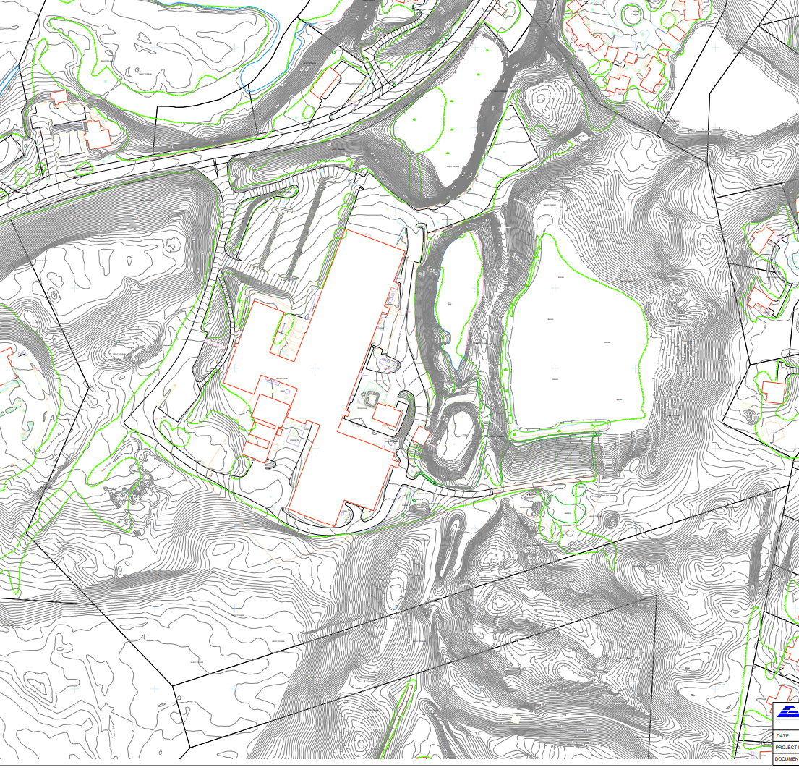

Needs of the Town and Preferences of its Residents
The third set of considerations was the assessment of the needs of the Town and the interests, preferences, support, and concerns of the public. As described above in Section 1), this consideration involved three waves of activities: discussions with town committees; the conduct of a public workshop; and the use of a public survey to assess preferences. The Committee was assisted in the public input gathering aspect of the “fact-finding” by an EPA contractor, SKEO, as described above.

As a result of all of these considerations, the precursor to the “Master Plan” was the identification of “development zones” within the site (see Figure 1.4 in Chapter 1). It should be noted that the Committee has not yet been considered the locations and nature of any and all infrastructure components (utilities, storm sewers; septic, roadways; access; etc.) that will be needed for the various possible reuses of the Site.

Summary of the Overall “Master Plan” and Possible Phasing Considerations
The history and natural features of the site have led the Committee to develop a master plan for the reuse/redevelopment at the site, based on the reuse zones shown in Chapter 1, Figure 4.2 below provides a visual depiction of the master plan. Details of the various reuse/redevelopment options are presented in the following sections, with reference to these “Reuse Zones”.

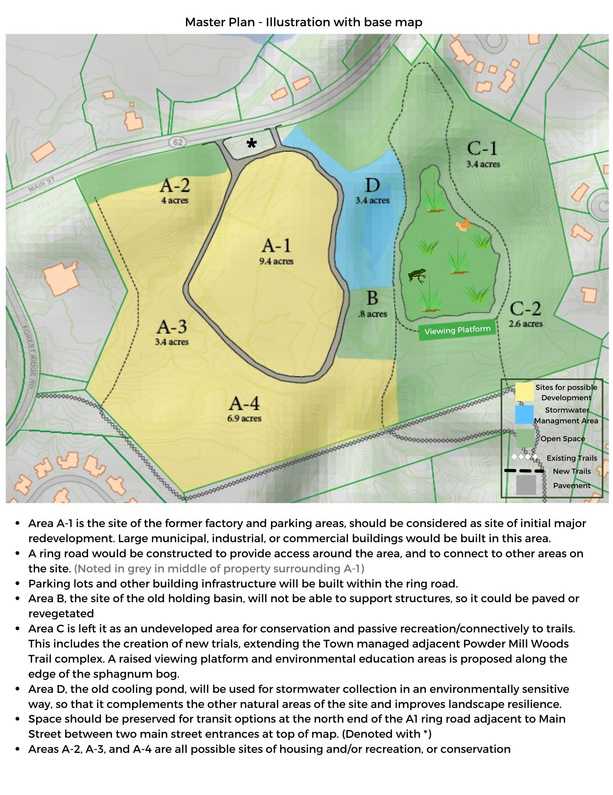

Figure 4.2. Visual Depiction of Master Plan.
The overall “Master Plan” includes four (5) central elements (items 1-5 below) and the consideration of various other potential development elements (item 6):

- Area A-1, the site of the former factory and parking areas, should be considered as the site of initial major redevelopment. Large municipal, industrial, or commercial buildings would be built in this area. The driveway, known as the ring road, would be improved to provide access around the area, and to connect to other areas on the site. Parking lots and other building infrastructure will be built within the ring road. Buildings will use environmentally friendly design techniques, including siting for optimal solar energy and/or geothermal energy generation. Buildings will also be sited to take advantage of the views of the conservation areas at the site.

- Area B, the site of the old holding basin, will not be able to support structures, so it could be revegetated with shrubs or potentially tree canopy over the cap. Some kind of open space is also a possibility for this area directly adjacent to the sphagnum bog, though the area should be graded away from the sphagnum bog to further protect this sensitive ecosystem.

- The overall consensus of the Committee on Area C for all options discussed below is to leave it as an undeveloped area for conservation and passive recreation/connectively to trails. This includes the creation of new trials, extending the Town managed adjacent Powder Mill Woods Trail complex (See Figure 4.3) to further enhance the use of and access to Zone C. Restoration should include new trails that connect to the Town managed adjacent Powder Mill Woods trail complex. A raised viewing platform and environmental education areas is proposed along the edge of the sphagnum bog, (which is already a popular trespassing site for bird watchers.) This planned use of area C supports the Committee redevelopment principles of environmental sustainability and community synergy by expanding the accessibility of these natural areas to a wider range of walk-in residents living nearby or other educational groups, while protecting the sphagnum bog.

- Area D, the old cooling pond, will be used for stormwater collection and groundwater recharge in an environmentally sensitive way using native plants, so that it complements the other natural areas of the site and improves landscape resilience.

- Space should be preserved for transit options at the north end of the A1 ring road, adjacent to Main Street. The plan should explore various options that ensure car-free access from both Concord Center and West Concord to the site for potential users as well as regional links and connectivity to neighboring the towns of Acton, Maynard and Sudbury.

- Areas A-2, A-3, and A-4, which back up to properties on Forest Ridge Road, are all possible sites of future development, but decisions on the extent of the development of these areas (including considerations of housing development on these areas of the site) most likely would occur after area A-1 is developed.

Committee deliberations and public input via survey results point to the recommended use of some portion of zone A2 for clean fill, which would facilitate its future development and, at the same time, might reduce the environmental impact of the remediation. Possible uses for these areas include power storage via a battery facility, or development ranging from outdoor recreation to construction of some type of building or other facility. Infrastructure requirements for the overall site, such as power or leach fields, may be satisfied by some development in these zones. The options presented below vary with respect to uses and timing of redevelopment in these zones.
Figure4.3. Section of Powder Mill Woods Trail Map showing potential trail links to Area C 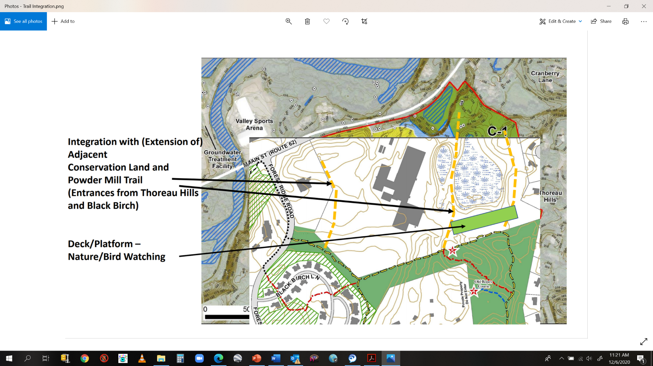

The Committee is well aware that reuse/redevelopment and especially the selection of options for Zones A2, A3 and A4 are not likely to begin for 4-6 years and will very likely extend well beyond that time period. However, interest and planning by the Town and/or solicitation of third-party interest is encouraged to begin before cleanup is complete. During the next 4-10 years priorities will change and/or come into clearer focus. Financial constraints and decisions, by third parties and/or by the Town will likely be engaged in phases.

Therefore, it is almost certain that phased re-development will occur. The Committee believes that one scenario that is essential and both practical and implementable is for a) the Town to take ownership of the Site, followed by b) the development of Zones A1 and C first, then followed by c) the potential reuse of other areas – or not – as Town needs/abilities/desires warrant or as third parties present opportunities to the Town.

Illustrative potential redevelopment options

4.2.1 Option 1: Municipal, Community, Recreational Focus

Overview
In keeping with the overall “Master Plan,” which focuses on reuse of area A-1 and the conservation of Area C for public enjoyment, this option centers on the creation of structures for the Town’s and area-wide public uses of the site overall. Especially significant is the adherence of this option to four or five of the six overarching principles articulated in the NSRC’s planning.

This option reflects both explicit and implied needs as articulated in various reports and plans developed over the past few years (e.g., The Comprehensive Long-Range Plan (Envision Concord – Bridge to 2030; the Recreation Department’s Facilities Strategic Plan; the Climate Action Advisory Board’s Climate Action Plan) as well as input received during the Public Workshop and Survey. It reflects both a need for future expansion of existing facilities as well as a need to fill gaps in both recreational and other community needs. Indoor recreational and senior facilities are currently largely centered in two limited and aging facilities – Hunt Gym and Harvey Wheeler – which, in turn limits, availability and access to such facilities for public enjoyment. Additional outdoor recreational assets are possible as part of this option as well.
The “Harvey Wheeler Community Center” serves as Concord’s Senior Center, a childcare facility and hosts municipal event space. It is a space-limited facility that is under heavy use pressure, yet future plans have the Council on Aging expanding the use of Harvey Wheeler for continued use as the Town’s senior center. Concord does not currently have a future looking “community center” for meeting and other multiple public uses purposes, a gap which is noted in comparison to adjacent Towns such as Lexington, Stowe, and Sudbury (current and future). An important benefit of this option is the integration of community center, ancillary senior programming, and indoor recreational center concepts. An indoor field house and indoor walking/running track were identified as some examples of specific needs. Additional indoor (winter) recreation in the West Concord area adjacent to area-wide commercial resources such as the Thoreau Club and Valley Sports was also noted.
Fiscal aspects of the development and operational aspects of implementing this option have not yet been evaluated (see “considerations” below).
The other part of this option refers to Area C. Approximately half the site will remain undisturbed only drawing on sustainable improvement to enhance the environmental conservation, possible environmental education, and outdoor passive uses (trails), part of the site’s improvement and reuse. Area C contains unique ecological and environmental educational asset including the sphagnum bog and adjacent wooded areas. It lies directly adjacent to existing Town-maintained trail, the Powder Mill Woods Trail, both accessible from the adjacent Thoreau Hills community, Black Birch development, and Thoreau Club property.
As mentioned in the “Master Plan” (Section 4.1) the value of this reuse will be greatly enhanced by improving access to these facilities from both Concord Center and West Concord. Further with emphasis on the Community Center concepts, the development of municipal assets here should blend well and not overly compete with private facilities of valley sports (skating; hockey) and Thoreau Club (tennis; swimming; etc.).

Description of Components, their uses and their potential users
A rough, conceptual schematic of Option 1 is shown in Figure 4.4. In effect, the option represents a limited public/municipal reuse of the site. The indoor community/recreation facility would be a 10,000 – 20,000 square foot facility with the following features:
- Field house/indoor recreation general space
- Workout rooms
- Walking track
- Meeting/event spaces
- Specific additional COA programs or events
Patterned after similar concepts (e.g., East Boulder Community Center, Boulder Co) there could be separate, but adjoining municipal facilities within the same structure.
Importantly, this option would support future growing multi-generational needs, from young families to aging residents. In addition, other municipal needs of the entire community, such as providing meeting spaces and available fee-related event spaces for private events, could be accommodated.
As part of this option the possible use of other areas for grassy recreational sues – baseball and soccer fields - could readily be included in conjunction with indoor facilities.
Further, a focus on community center and recreation here should not preclude other municipal uses of the site, such as Town offices within the complex.
As the option would include a ring-road for intra-site facility access and parking facilities to accommodate the uses of the site, an additional bus-transit stop embedded within the parking facilities could afford public access to the site from other parts of town without the need for automobile transit to the site.
Lastly, and importantly, the conserved environmental conservation, passive recreational area could provide valued trails for walking and winter cross-country skiing; nature viewing via the construction of viewing platform connected to the community center or standing alone within the elevated areas of Zone C. Users would include the multigenerational public as well as possibly school groups using the site as an environmental education asset.
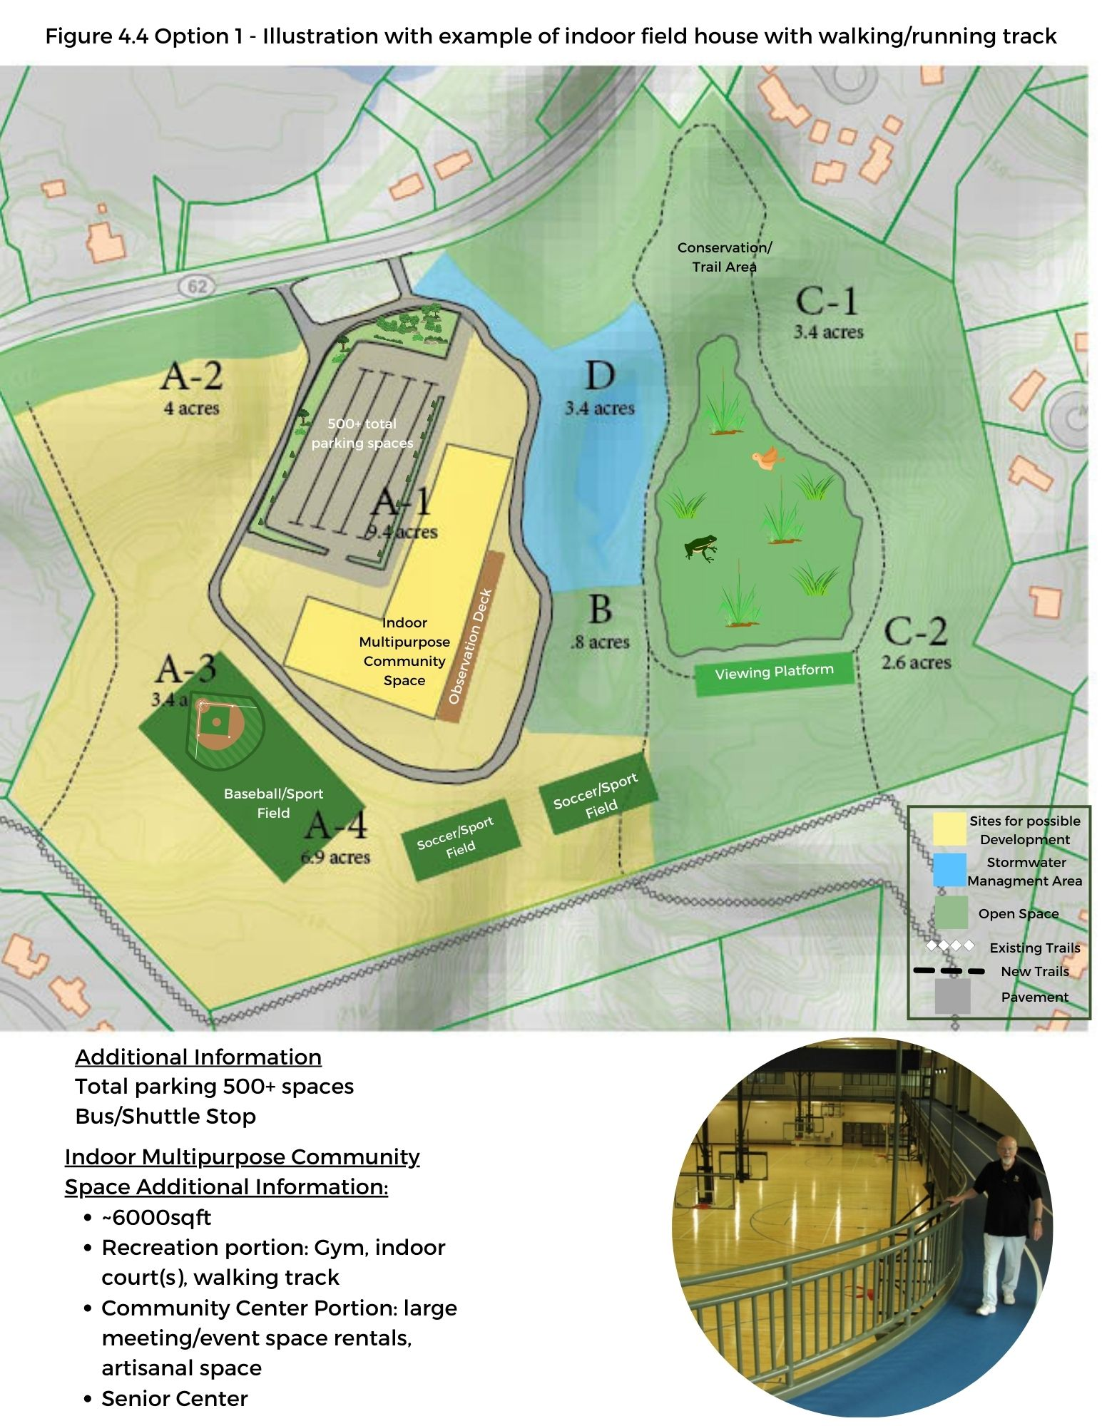

Considerations, issues, constraints
Several key considerations will need to be considered in the planning and implementation of this option:
- The development of not only an overall “Public Use Plan” but the specific composition of the indoor recreation/community center. A planning committee would need to be formed as part of the current NSRC or as a cross committee effort among committees on recreation, council on aging, and natural resources,
- Consideration of this option would need to be part of a broader planning exercise across the Town as other facilities evolve in their uses (e.g., Peabody School; Harvey Wheeler Community Center),
- The new committee would have to consider both the strategic needs of the Town as well as the specific needs of the Town’s residents,
- The coordination of indoor and outdoor uses and assets of the site,
- Who would develop the option (see next section)
- What on-site infrastructure requirements are needed to support the option and their costs,
- Whether this plan would be revenue neutral, or require revenue enhancements and if the latter, how to enhance revenues through users’ fees, rentals etc., and
- Phasing consideration of retaining future development potential for A2, A3 and A4.

Potential implementation options (who develops it)
After the Town takes ownership of the site, there are basically two overarching options for the development of the recreation/community center and site infrastructure development and site improvements to accommodate the Area C development – Town financing and development; third party development (See Section 3.4). Within the former, in addition to “normal” capital planning process, options for state and federal grants and/or use of settlement funds from the natural resource damage assessment process as part of the overall Superfund cleanup, can and should be considered. Third parties might be attracted to the site if tax and leasing considerations were made articulated. Alternatively, once developed, the site could be managed along the lines of the Recreation Department’s operational model (i.e., the Revolving Fund) as an adjunct to the current Department or as a separate entity that could be developed to establish a fee-based system to cover operating costs.

How option supports the principles
Option 1 presents a diverse set of community uses, meeting needs across several Town demographics – youth, adult, seniors. The focus on recreation and community uses, integrated into outdoor recreational and natural resource conservation elements, strongly emphasizes the non-commercial core elements of community synergy, environmental stewardship, and multiple integrated uses for the benefit of the Town. Though initial financing options are varied and well-known to the Town (including possible public/private financing – see Section 3.5), the fiscal viability and sustainability of the operations of this option can clearly follow other successful models in the Town (e.g., Recreation Commission Revolving Fund) where a separately managed user fee-based system works very well to ensure that this option meets the fourth principal – fiscal sustainability.

Box 4.1 Presents a specific example of how Option 1 has played out in another community as demonstrated in East Boulder, Colorado.

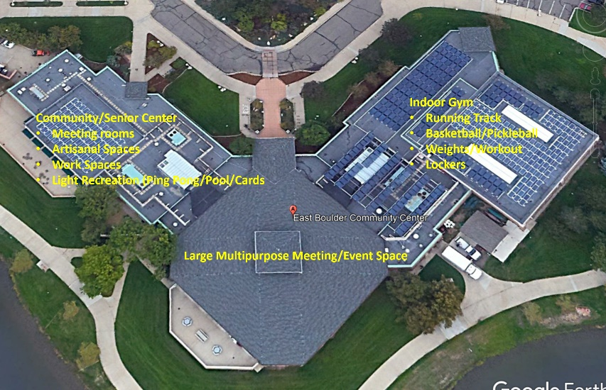
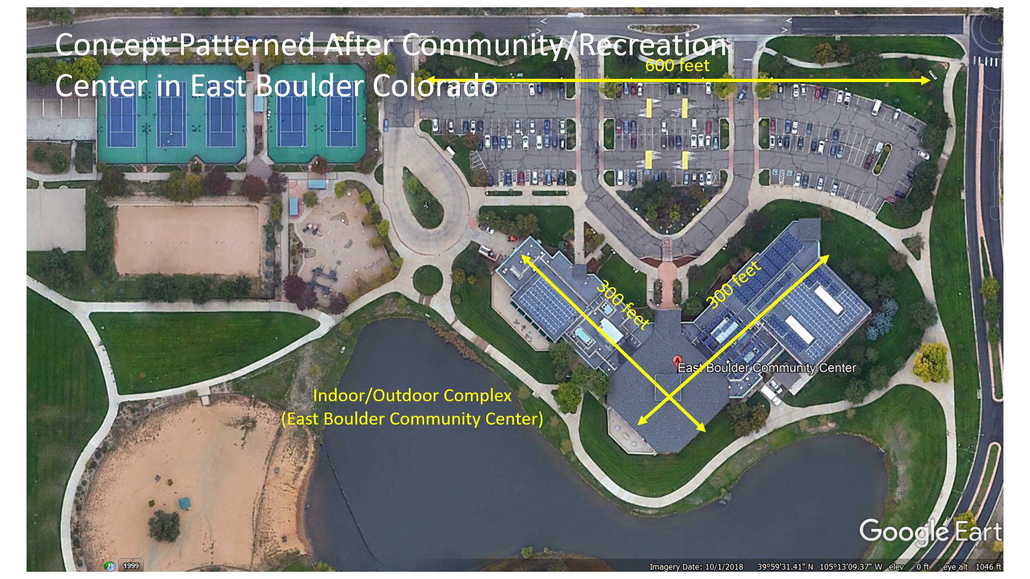
Box 4.1 Example of Integrated Community – Recreation Center (Example from East Boulder, CO)

The multigenerational appeal of an integrated indoor-outdoor community, senior, and recreation center is exemplified in a specific example, which has intrigued some members of the NSRC. The East Boulder (Colorado) Community Center is a ∼30,000 sq. foot complex which houses a senior center, small and large meeting and function spaces, performing arts facilities, classrooms, and varied indoor recreation modules – walking track, gymnasium, weight room, locker rooms, etc. – adjacent to outdoor sports fields. The 4-season complex is served by a large amount of parking and is accessible via a town shuttle and bus routes. The indoor facility is integrated with a complex of outdoor tennis courts and playing fields. Services and facilities are both by reservation and open access and operations are covered by annual fees and one time use fees for the varied facilities. One of the attractive attributes in the East Boulder complex is the availability of facilities and activities for kids, adults, and seniors especially in the cold, snowy winter months when outdoor facilities are not readily useable and other available indoor facilities may be overtaxed.

Though all the East Boulder components may not be needed in Concord, such a multipurpose facility would serve not only the immediate West Concord population and the entire Town, but would be an asset to adjacent communities as well.

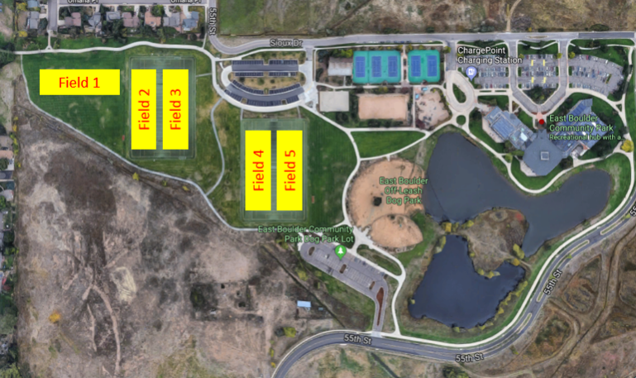

4.2.2 Option 2: Private/commercial/office use focus

Overview-description of the option
The 2018 Envision Concord Plan, in its presentation of Economic Vitality issues, noted that Concord faces economic trends and local conditions that threaten its long-term economic health. These threats include the changes in business technology, a difficult local business environment due to changing property ownership and increasing rents, and limited civic and government capacity to support and guide economic development. Concord’s economic base has been in decline from 2005 to 2015 (down 6%) while both Middlesex County (up 11%) and Massachusetts in general (up 8%) have increased.
The NMI-Starmet site represents an opportunity to improve Concord’s economic vitality by providing a new location for business and commercial growth that supports an active self-employed and entrepreneurial population, while providing a larger commercial property tax base that will help fund the Towns services and could help modulate increases in residential property taxes. Additionally, this location could help provide business ownership and employment opportunities for Concord residents while strengthening Concord’s connection to the region.
Option 2 is designed to expand the commercial and light industrial base for the community by promoting development of Area A1 as an additional medical or office complex that could provide another remote location for ER/medical offices for Emerson Hospital Complementary and supporting office and/or laboratory uses would also be encouraged. This option concentrates new development on Parcel A-1, the portion of the site that was previously built out, preserving the existing ecology and landscapes on other portions of the site. Additionally, other areas of the site (Areas A2, A3 and A4 - where there has been little or no identified contamination) could be developed for residential use as a Planned Residential Development, which would potentially provide housing for those employed at the various medical offices and facilities nearby (See Figure 4.5).

Description of Option 2 Components, their uses and their potential users
Option 2 includes several facets and alternatives:
- Commercial/light industrial space to provide medical offices, laboratories and associated medical services (outpatient/ER/MRI).
- Outdoor recreation
- Close to 100 new housing units, which allows for a sizable affordable/workforce housing component.
The size of the original NMI-Starmet building was about 185,000 sq. ft. all on one level. This scenario is based on building a two- or three-story building to create 300,000 sq. ft. on the A-1 area, which may include a parking garage as a portion of the first-story in combination with open at-grade parking lots. The roof and the parking lots should be designed to accommodate photo-voltaic arrays that would tie into the Town’s grid.
Areas A-2 and A-4, two areas not used for manufacturing or waste disposal, could be developed through the application of the Planned Residential Development process yielding 80 to 100 units of mixed unit sizes of housing for rent or for purchase. Area A-3 could serve as the location of an on-site septic system that would support these residential units. Additionally, there is likely sufficient area in the A-4 area to support creation of one or two playing fields that could serve the community.

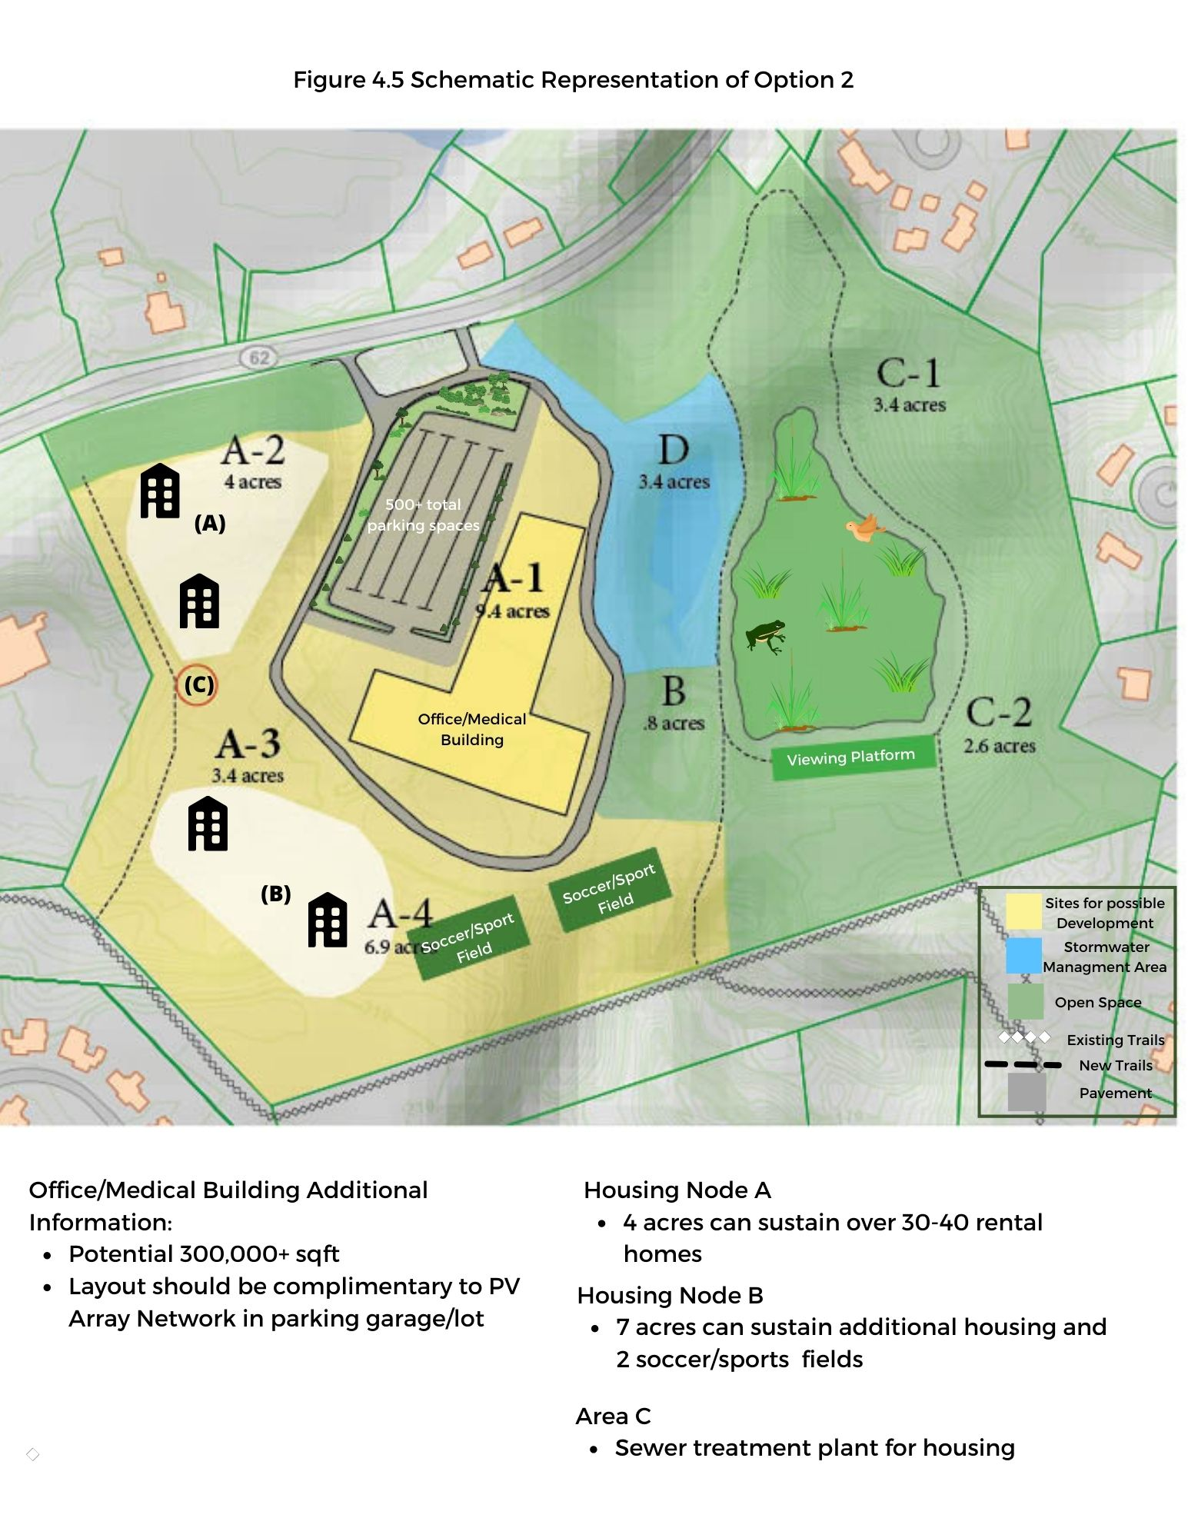

Several key issues and considerations need to inform future decisions about this option:
- What level of market support exists for additional medical office and related/supporting business uses and how does this inform the development on A-1.
- How do the on-site infrastructure requirements and their costs for this option compare to other options?
- What is the overall fiscal impact of this option on Concord? Will the higher tax and land lease revenues under this option offset its impact on any added town costs for infrastructure and services? How can the substantial new tax revenue generated from the density and mix of uses be optimized? What are the fiscal tradeoffs between Town development versus ground-leases?
- What is the best plan to address site parking and transit/alternative transportation needs?
- The appropriate mix and density of the housing component of this option to address Concord’s need for more diverse housing options while ensuring a financial viability given the desire to include affordable housing component.
- Phasing consideration of retaining future development potential for A2, A3 and A4

Potential implementation options (who develops it)
This option will likely be implemented through one or more private developers under town controls and guidelines established through zoning and a land lease agreement. Option 2 seems particularly amenable to a long-term ground-lease where the Town would negotiate with a private developer terms for a 50-99 year lease for the land. The private developer could then – subject to requirements, such as the verification and maintenance of institutional controls or other project objectives – independently re-develop and operate a portion of the site as the proposed development described above. The negotiation would determine whether the private developer retains all or a portion of the operating revenue and the tax structure for the land.

How option supports the principles
Option 2 is well aligned with the redevelopment principles articulated by the NMI/Starmet Reuse Planning Committee.
- Multiple Integrated Uses: This option emphasizes returning the property to commercial./light industrial uses that support the community’s economic vitality and increases opportunities for local entrepreneurs and workers.
- Environmental Stewardship: It has been noted in the Envision Concord plan that Concord has limited land and building sites for new development opportunities; by concentrating the commercial/light industrial development on the A-1 portion of the site, this option returns the property to a valuable commercial use. The building scale and construction, and implementation of solar energy use provide opportunities to achieve a net zero energy and carbon neutral development. Developing the A-2, A-3 and A-4 areas using the Planned Residential Development option will allow houses to be clustered on portions of the site where there was little or no contamination from prior uses.
- Fiscal Sustainability: This redevelopment option can return the property to the tax rolls thereby strengthening the town’s economic base, which will have a positive effect on the taxes. The businesses that operate here will also create jobs for local residents, which in turn can have a positive effect on quality of life. This option promises to generate multiple sources of revenue to achieve fiscal sustainability: land lease revenue; property taxes from the commercial and light industrial uses, in addition to the residential uses. These additional revenues will help to maintain the high level of services on which the community depends.
- Community Synergy: This option strengthens the community and Concord’s relationship with neighboring towns by providing much needed services for residents in this region. It provides new opportunities for people to be able to live, work and play in the community and supports site accessibility to local neighborhoods and surrounding communities. The housing mix envisioned under Option 2 will promote social and income diversity in Concord

Box 4.2 Presents a specific example of how Option 2 could play out with the right anchor tenant.
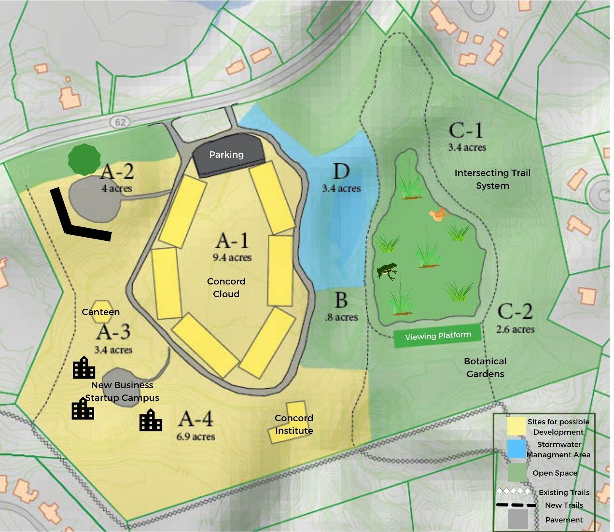
Box 4.2 Variation on Option 2: Concord Cloud-Concord Institute (developed by Brian Rosbrough)
One specific possible variation on Option 2 is conceived around three overarching themes: low residency, high social impact. and economic return on investment for the Town. The example It is anchored by a two-tenant solution:
- Concord Cloud (CC), a public i-Cloud service provider. Anchor Tenant: Amazon, Google, Microsoft, IBM, Oracle
- Concord Institute (CI), a non-profit partner enabling future visions, innovative startups, and public service solutions for Concord, New England, the Nation, and the World.
The integrated elements would also be characterized by sustainable design standards. This example envisions a phased limited and transient occupancy of the site, followed by future developments that meet Town needs when the site may be desired for future occupants wanting long-term residency after all residual risk communication issues have been resolved. This example envisions leasing of areas of the site from the Town by two tenants: Concord Cloud Computing Center (CC) and a companion Concord Institute (CI) with smaller supportive facilities located on A-2, A-3, A-4, and C-2. None of these facilities would require long term overnight residency, but transient public access is anticipated. The Anchor Tenant could possibly be one of the major tech owners of public Cloud services. The CI, which would be funded by the owners of the CC is envisioned to be an educational facility along the lines of other such non-profits such as the Aspen Institute, which provides facilities and meeting spaces for diverse set of activities aimed at sustainability, and environmental stewardship. It’s location, adjacent to the sphagnum bog area and the passive recreational uses of that asset as described above in Option 1, creates important synergies in that Anchor Tenant, Concord Cloud, would build and support Concord Institute as a civic partner to attract intellectual and educational clients, expand its public service business.

One schematic is presented below .The core CC facility would be located inside of the ring road in the area of the removed structures. The facilities envisioned to support CC and the Institute would be outside the perimeter of the ring road, much smaller in scale, but built to comply with the highest sustainable design standards advanced by LEED and LBC (Living Buildings Challenge). As envisioned, all facilities (first occupants) on campus will be networked to share utilities, Cloud communications, and engineering infrastructure that achieve a low carbon footprint and allow for easy conversion to future uses of the property. One of the key considerations for the development of the CC is the question of energy requirements and sustainability. The concept here calls for a carbon neutral design and operation with sustainable energy principles.

4.2.3: Mixed Use Focus - Housing, retail, and commercial uses

Overview-description of the option
For over 50 years, the Town’s boards and committees have worked to increase housing diversity in town through plans, reports, and actions. However, further expansion of the diversity and affordability of housing options in Concord remains a critical need.

Concord residents tend to speak abstractly in favor of more housing options – not necessarily just low-income housing but more “diversity” (price range, sizes, accessibility, location). They feel that housing should meet the needs of Concord residents – i.e. “workforce” housing for those of moderate incomes – and that new housing should not be built on the Town’s few remaining “green fields” (open spaces/undeveloped land). With the exception of the Planned Residential Development zoning provisions and two-family dwellings, current zoning limits the development of more flexible housing types, such as multi-family dwellings and limits greater density on lots. Zoning is a major constraint in diversifying Concord’s housing efforts, because over 90% of the town is zoned for residential use, and the development pattern has been primarily single-family housing.

Thus, the A-1 parcel represents a key opportunity to achieve diversification of Concord’s housing stock consistent with the Town’s recent long-range plan. This parcel is nearly ten acres that will be cleared, excavated and restored in a manner consistent with redevelopment, saving significant upfront site costs for a development project. Nearby parcels (e.g. portions of A2 or A-3) can support septic, heat pump wells or other infrastructure needs). Critically, when viewed through the lens of the Implementation Checklists included in the Town’s long-range plan, such a development should also consider linkages to transportation and accessibility of housing to basic needs, the fiscal sustainability of new developments (i.e. impact on tax base) and the environmental sustainability of such a development. This option being proposed - consistent with the “Master plan” concept - is for a mixed-use development that would include housing units alongside a node in a new public transit link to the village centers, above commercial and retail spaces and possibly artisan workshops, and providing a sustainable and vibrant living environment for those of modest means who wish to either downsize and remain in Concord or transition back to Concord after college. Furthermore, this option concentrates new development on Parcel A-1, the portion of the site that was previously built out, preserving the existing ecology and landscapes on other portions of the site.

Description of Option 3 Components, their uses and their potential users
Although the exact complement of new uses under this option will be depend on market conditions and detailed site/development planning when reuse implementation occurs, an illustrative mix of uses is presented below and visualized in Figure 4.6. This scenario is based on building four-story buildings on the A-1 zone with a combined footprint of 100,000 square feet. At 23% of the 9.4-acre parcel, this will still leave much of the site available for parks, open space and other amenities while also accommodating an access road and parkway. This type and scale of mixed-use development would deliver considerable benefits to Concord:

- Close to 200 new housing units, which allows for a sizable affordable/workforce housing component.
- Substantial space (50,000 SF) for new entertainment or recreational uses, or municipal uses such as specific COA programs, Town workshops or other functions.
- Commercial/retail space to provide new amenities and new businesses and services.
- Flexibility to incorporate emerging and specialized needs for artisan workshops, coworking space, research, or start-up enterprises.
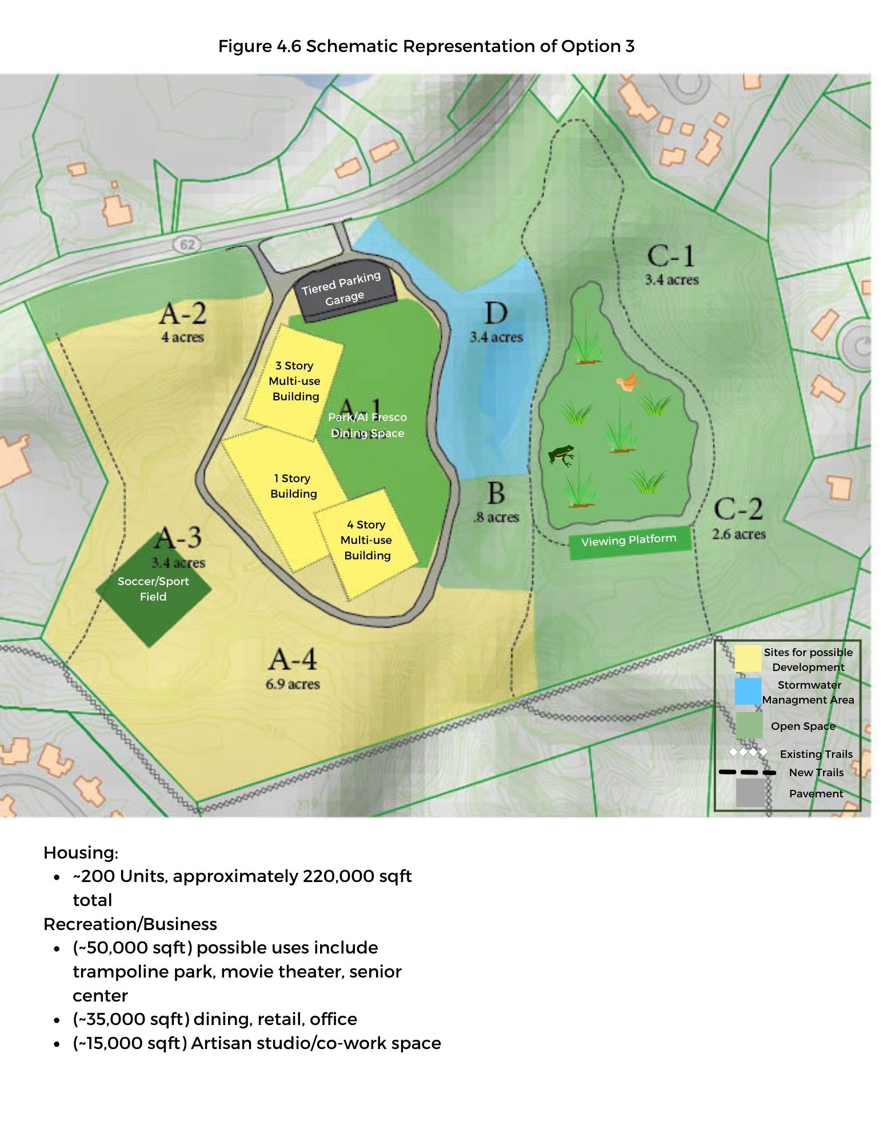

- Potential for town revenue through land sales or leases
- Substantial new tax revenue generated from the density and mix of uses.

Several key issues and considerations need to inform future decisions about this option:

- The appropriate mix and density of the housing component of this option to address Concord’s need for affordable units and non-single family options while ensuring a financial viability given the subsidies needed for affordable housing.
- What level of market support exists for office, retail, and other business uses and how does this inform the mix of uses, scale and phasing of development on A-1.
- Will subsidies be needed to provide low-cost artisan/co-workspace or can the cost to provide such space be covered by market rents from other uses?
- How do the on-site infrastructure requirements and their costs for this option compare to other options, given the number of housing unit anticipated?
- What is the overall fiscal impact of this option on Concord? Will the higher tax and land sale/lease revenues under this option offset its impact on any added town costs for infrastructure and services?
- What is the best plan to address site parking needs and to accommodate a transit hub and include bus parking on the site? How does the transit hub/bus parking impact Concord’s cost and revenues as well as rents and desirability for housing and business uses?
- Phasing consideration of retaining future development potential for A2, A3 and A4

Potential implementation options (who develops it)
This option will likely be implemented through one or more private developers under town controls and guidelines established through zoning and a land disposition or lease agreement. Chapter 4 includes a section describing several potential institutional arrangements for ownership of the parcel. Option 3 seems particularly amenable to a long-term ground-lease where the Town would negotiate with a private developer terms for a 50-99 year lease for the land. The private developer could then – subject to requirements, such as the verification and maintenance of institutional controls or other project objectives – independently re-develop and operate a portion of the site as the proposed mixed-use development described above. The negotiation would determine whether the private developer retains all or a portion of the operating revenue and the tax structure for the land.

How option supports the principles
Option 3 is well aligned with the redevelopment principles articulated by the NMI/Starmet Reuse Planning Committee.
- Multiple Integrated Uses: Redevelopment should address multiple needs identified by the community. This option emphasizes mixed-use redevelopment with the capacity to address a range of community needs including new housing options, housing affordability, new recreation facilities, diverse business types, affordable artisan space and municipal services.
- Environmental Stewardship: By concentrating development on the A-1 partial, this option preserves the environmental assets on the balance of the site, particularly parcels A-2, A-3 and A-4. The building scale and mix of daytime and night-time use provides opportunities to achieve a net zero energy and carbon neutral development. It provides more space for roof top solar and can allocate the costs for building innovation and energy systems across more square feet and a large base of tenants and users.
- Fiscal Sustainability: This option enables creative ways to fund reuse. With an emphasis on market-driven uses, this option promises to generate multiple sources of revenue to achieve fiscal sustainability: land sales or lease revenue; property taxes from housing and commercial uses, and meals tax revenue from new restaurants. The number of occupants and scale of revenue increases the feasibility of funding site infrastructure with limited use of the existing tax base by utilizing, fee, assessments and taxes from new development and users.
- Community Synergy: This option strengthens the community and our relationships with neighboring towns. It provides opportunities for people from diverse social groups to interact as they access services at the site, and supports site accessibility to local neighborhoods and surrounding communities. The housing mix envisioned under Option 3 will promote social and income diversity within both Concord and the new district built at the site. By incorporating a diverse mix of uses, it will provide opportunities to serve residents and entrepreneurs from neighboring towns along with those in West Concord and the adjacent neighborhoods.

Box 4.3 Presents a variation on the mixed-use theme of Option 3. As noted in the text, it does not take advantage of Option 3’s emphasis on vertical yet compact development to increase density of development, preserving surrounding area; however, it offers an interesting opportunity to take advantage of the site’s combination of large development potential with nearby natural features.
Box 4.3 Mixed-use alternative to Option 3: Tiny House Village (contributions from Haley Orvedal)
The tiny-house movement (also known as the "small-house movement") is an architectural and social movement that advocates living simply in small homes. Those who buy come from all parts of the economic spectrum. Often, tiny houses are home to one or two people, though the larger homes can accommodate more. Tiny houses had become increasingly popular even before the coronavirus shutdown in March, but business has since gone from growing rapidly to growing exponentially. For some, rather than living in a condominium, co-op or apartment in close contact with neighbors, living in a tiny house village sets houses apart with adequate space for social distancing.

Pandemic aside, a “tiny house village” eliminates the need to find a place where the structures are allowed under current zoning regulations and laws on the state and local level. An overlay district within redevelopment zone A-1 could be zoned specifically to offer 7-8 acres of tiny house-friendly zoning regulations adjacent to a 2-acre retail and commercial district to complement the village. A private entity or a public-private partnership could own or lease the land, and home purchasers pay a monthly rent for the site their house occupies within the village. Pre-fabricated units for sale might make them more affordable.

A small retail district could include coffee shops, restaurant, dry cleaner, hardware and meet other daily needs. A transit connection to West Concord village enables additional essentials and broader public transportation needs to be accessed. While still mixed-use, this example differs from Option 3 in critical ways since it does not emphasize denser/vertical development within A-1 complemented by preservation of surrounding re-development zones.

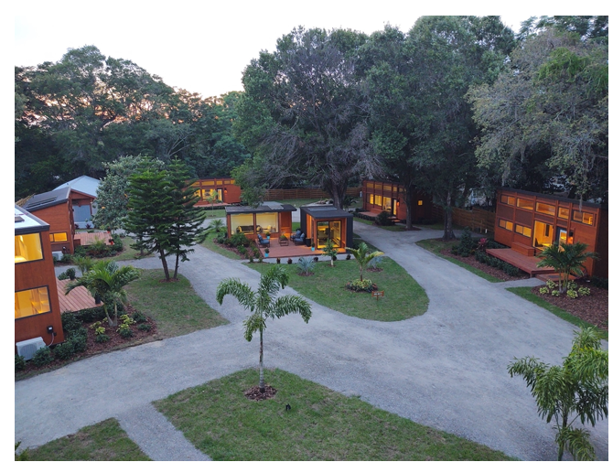

Recommendations and Next Steps: A roadmap to redevelopment
This report fulfills the initial charge of the NSRC to review the record of environmental contamination and cleanup proceedings at the NMI-Starmet Superfund site, to solicit feedback and input from the Town and to identify possible ways to reuse the site for maximum public benefit. Recommendations regarding next steps are intended to assist the Select Board in identifying high priority areas for actions and decisions.

The NSRC has conducted research on issues of risk communication around environmentally contaminated sites, appropriateness and need for housing at the site, recreation needs of the Town, potential options for taking ownership of the site, finance considerations, the context of other Town development efforts as well as relevant examples of other Superfund site redevelopment. Using this research and several forms of public input and feedback, the Committee has developed an overarching “Master Plan” concept for redevelopment of the site and then identified three potential redevelopment options that fit within the “Master Plan” framework. Each of these options has been assessed against committee principles for redevelopment, namely the inclusion of multiple uses, environmental and fiscal sustainability and community synergy.

Based on consideration of each of the issues researched in Chapter3 and based on the need for further consideration of the three primary redevelopment options presented in Chapter 4 (as well as the many potential variations on those three concepts), the NMI/Starmet Reuse Planning Committee strongly recommends that the Town of Concord begin planning to take ownership of the parcel at 2229 Main Street and to start active planning for the “Master Plan” concept for redevelopment for the site. This has several immediate planning implications as well as several longer-term planning implications which are outlined below.

Action to develop a process and path for acquiring the site is a high priority for 2021. Key short-term actions for the Select Board to consider include engaging the Town Counsel to focus on 1) identification of current site ownership (i.e., confirming that the site does not presently have a standing owner); 2) confirmation of all liens (see Annex A) and any other potential future liabilities; 2) related to liabilities, engage with EPA to fully explore the Superfund’s program for limitation of liability of prospective municipal buyers: 3) research opportunities to settle/release liens against the property as a precondition for taking ownership. Secondarily, outside counsel should investigate further the various institutional relationships identified in Section 3.5.

Additionally, the Select Board through the NSRC should provide guidance to de maximis regarding area-specific cleanup provisions that intersect with redevelopment:
- The Town supports the use of clean fill from some portion of redevelopment zone A2 to replace soil removed during remediation actions in A1 and A3. The extent of soil use from A2 will depend upon the results of the net benefits environmental review that is currently being carried out by de maximis, which considers other factors such as the net stormwater, carbon sequestration and air pollution impacts of mature tree/truck movement implications of various fractions of A2 usage and availability of other sources of clean fill.
- The Town should ensure that a wooded buffer remains along route 62 to provide screening of the site from Main Street. The balance of clean fill needed should be considered in the context of other Town activities such as the 1440 Main Street subdivision being planned or the dredging of Warner’s Pond.
- The Town should convey the type of desired finish over the cap of the Holding Basin (Area B). The committee supports the NRC recommendation to revegetate Zone B with native plants and grade it away from the Sphagnum bog.

Next, the Town should decide on a planning mechanism for the site’s redevelopment. Options include renewing or revising the charge to the NSRC. Another option would require more direct Select Board involvement but may result in more integrated planning within Town government. Namely, a Select Board Member could host quarterly calls with one representative of the Planning Board, the Recreation Commission, Natural Resources Commission and the Finance Committee who would integrate various planning aspects of the work within their existing mandates. Eventually, as appropriate, other committees (e.g. CHDC or Light Board) might also be engaged.

Finally, in the near term, the Select Board should initiate risk communication efforts as described in Section 3.1 of the report. The NSRC feels that it is critical to the success of any redevelopment effort that the Town get out in front of the negative stigma that may already exist toward a Superfund site independent of the extent of remaining contamination and the extensive cleanup being planned. The Town must communicate facts to Town residents regarding the absence of any significant residual human health or ecological risks at the site once cleanup is completed and institutional controls are in place. Further, the communication needs to articulate the general Superfund provisions and specifics articulated in the Consent Decree for the Site that protect the Town from incurring future liabilities related to “unknown” or “unforeseeable” contamination present at the Site..

Longer term the Select Board should consider several principles of redevelopment based on the NSRC’s review of issues in Chapter 3:
- First, the Committee believes that it is imperative that only redevelopment options that result in no net fiscal impact to the Town be considered. The Town is not currently in a financial position to support additional amenities or services that will negatively impact the median tax rate.
- Given the Town’s commitment to sustainability principles and the Article 51 commitment to significant GHG reductions over the lifetime of the any NMI-Starmet redevelopment project, the NSRC recommends adoption of a Devens-like sustainability overlay zoning district that will require all-electric, net-zero development, with other sustainable land-use requirements. These sustainability goals are further supported by elements already included in the “Master Plan” description, including transit connectivity, distributed power storage for the CMLP grid, and landscape resilience in the form of potential flood storage in reuse Zone D.
- The NSRC recommends that all potential development plans include consideration of housing options. It is rare for such a large, buildable parcel of land to become available in Concord, and given the tremendous needs for different types of housing in Town, we should at least consider the possibility of development that meets our key housing needs (whether that be affordable, workforce, starter homes, tiny homes or otherwise) at this site.

The Town should also consider engaging with third parties to gauge demand for various redevelopment investments and partnerships. For example, Option 2 would require demand for a certain level of medical office space, which may or may not exist five years hence. A market demand analysis may not need to be undertaken by the Town but may already be established by health partners in the area such as Emerson Hospital or Mass General Brigham. Similarly, the variation on Option 2 is critically dependent on an anchor tenant with need for cloud computing/server farms located in metro-Boston. Success of mixed-use developments would similarly depend on the demand from developers. The Town should informally begin these outreach efforts to help assess the success of the various options.

In parallel with other planning efforts, the Town should commission the Finance Committee to undertake a fiscal impact study to better understand the costs and revenues to Concord under the different reuse options. While the fiscal impacts are obviously critical to any decision-making around options, the Town also needs to begin to blend NMI-Starmet Site redevelopment discussions into other Town-Wide Planning, including how to reconcile any town capital investment needs for reuse with overall long-term capital investment needs and resources.

Annex A: SKEO Report

Annex B: Community Survey Results

Annex C: Relevant Superfund Redevelopment Examples

Annex D: Consent Decree

Annex E: Liability Protection Information from U.S. EPA

Consent Decree ¶75-79
https://www.epa.gov/sites/production/files/2020-06/documents/local-gov-acquisition-guide-final-2020-esign.pdf
The legal document binding the responsible parties is known as the Consent Decree for Remedial Design / Remedial Action (Civil Action No. 1:19-cv-12097-RGS) (the “CD”) binds the United States and Settling Defendants to perform all the “Work” required under the CD (see ¶2). In this legal document all Responsible Parties, legally referred to as the Settling Defendants (SD), have committed to pay for and perform the Work. Settling Federal Agencies agree to pay for the work. The amounts and allocation provided in CD ¶14 allow EPA to modify the work as needed to achieve and/or maintain the Performance Standards for work consistent with the Scope of Remedy provided in the Statement of Work (SOW) attached to the CD. CD Section VII provides for Remedy Review, and selection of further response actions, if needed to protect human health and the environment. Such further work is subject to reservations in ¶¶s 77 and 78, which allow for further response if conditions or information not previously known to EPA are discovered that indicate the remedial action is not protective of human health or the environment.
See CD ¶ 22.
According to the CD, a Trust Fund to pay for the Work is required to be established by CD ¶37. The Trust Fund will be funded using transfer of residual funds (~$21 MM) from the removal action work, an immediate $50 MM after EPA’s approval of the trust, and a further $53.8 MM one year after the initial payments (see ¶¶s 32.b., 33, and 37). The transfer and immediate payments were completed in February 2020, and the remaining payments are due in February 2021. Importantly, it is stipulated that If the amount of money is less than the sum projected necessary to perform the work for the next 36 months, CD ¶¶s 41 – 48 provide the process to obtain additional funding.
https://www.epa.gov/sites/production/files/2020-06/documents/local-gov-acquisition-guide-final-2020-esign.pdf
Section IV.A.2 in, https://www.epa.gov/sites/production/files/2020-06/documents/local-gov-acquisition-guide-final-2020-esign.pdf
Transmittal of the 2019 Policy on the Issuance of Superfund Comfort/Status Letters (epa.gov)
http://www.concordrec.com/245/Recreation-Facilities-Strategic-Plan. Note that the Recreation Commission is currently in the process of updating this plan.
http://www.ccyb.org/
Description of ground-lease from Investopia website: https://www.investopedia.com/terms/g/ground-lease.asp
Again, the description of public-private partnerships draws heavily from the Investopia website: https://www.investopedia.com/terms/p/public-private-partnerships.asp
Capital expenditures or outlays are defined as the use of funds to acquire or enhance productive assets that have a life expectancy of at least two years and a cost of least $5,000 and are intended to improve service capacity or efficiency.
Deed restrictions will prohibit the use of any groundwater from the site and will place one area, “the Holding Basin” area off limits for any construction.
https://www.lexingtonma.gov/community-center
https://www.stow-ma.gov/building-department/pages/pompositticut-community-center
https://sudbury.ma.us/locations/fairbank/
https://sudbury.ma.us/fairbankstudy/2015/03/30/see-plans-for-new-fairbank-community-center/
https://bouldercolorado.gov/parks-rec/east-boulder-community-center
https://concordma.gov/DocumentCenter/View/4211/Recreation-Commission-Revolving-Fund-Bylaw-PDF?bidId=
top-10-ques.pdf (epa.gov)
“NMI Reuse/Liens Updates”; September 23, 2020 Email from Christopher Smith, EPA Site Manager, to Gary Kleiman et al.

